St Stephen’s Church Fradley Advent & Christmas Events 2025

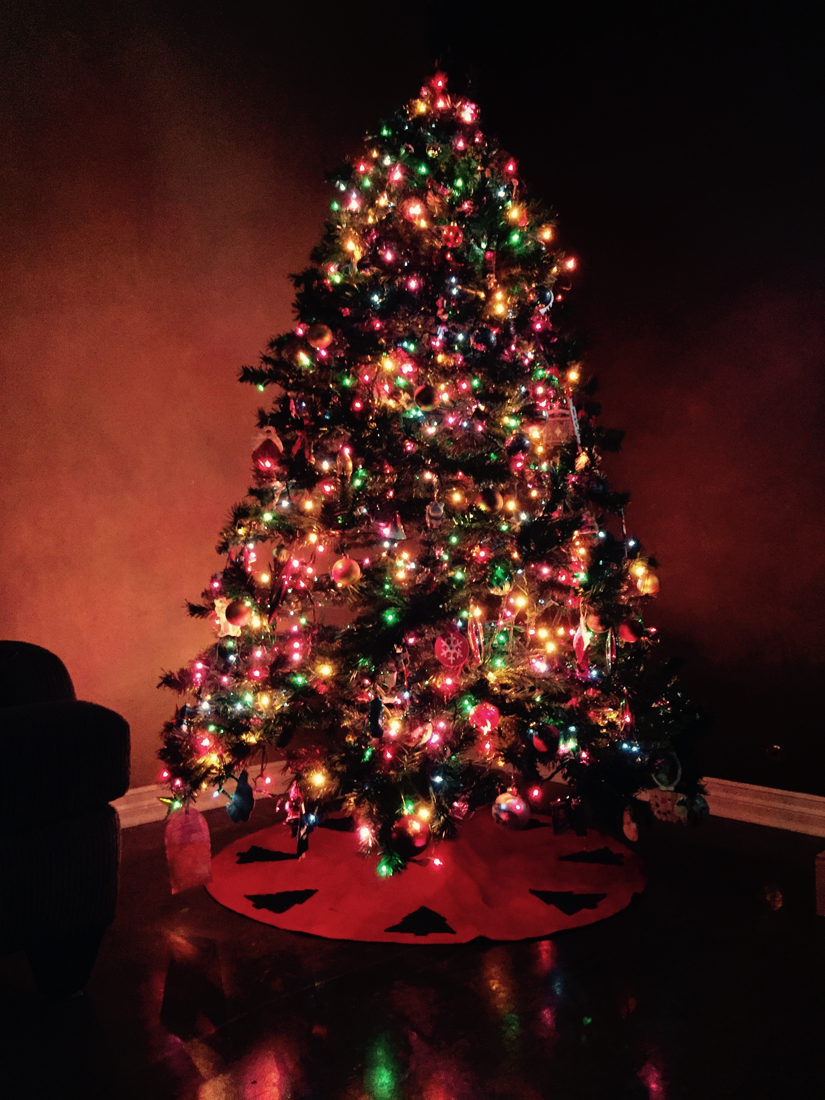
Wednesday 17th December
2pm Places of Welcome Carol Service followed by the usual places of welcome hospitality

Saturday 20th December
10am 12noon CHRISTMAS TREE FESTIVAL begins
Come and admire the wonderful Christmas Trees. Coffee and Cake served.
12noon Hamper Raffle Draw The Festival continues until 29th December

Sunday 21st December
4pm LESSONS &CAROLS by CANDLELIGHT Mulled Cider and Mince Pies
will be served

Wednesday 24th December
4pm Birthday Service Children are invited to come dressed as a character from the Nativity Scene as we retell the age old story of The Birth of Christ.
11.30pm Midnight Service by Candlelight
The first Communion of Christmas with Traditional carols and music led by our Music Group

