Remembrance Sunday
Act of Remembrance
Sunday 9th November
at 10.55am
War Memorial
Holy Trinity Church, Lydham
followed by service in church
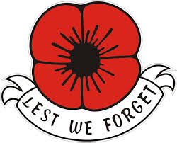
This is a join Act of Remembrance with the churches and communities of
Hyssington, Lydham, More, Myndtown, Norbury, Ratlinghope Snead & Wentnor

Please gather from 10.40am onwards so we can start promptly

