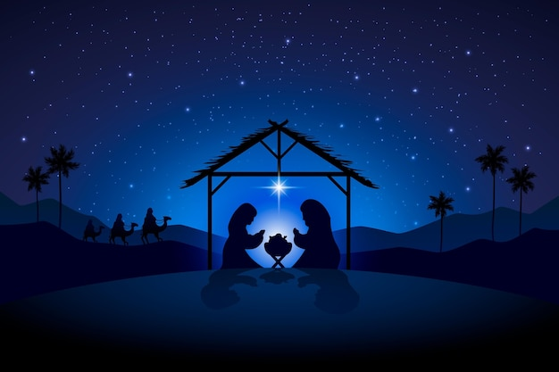
St. Michael and All Angels,
Marden
Christmas Services 2025
14th December - 3rd Sunday of Advent

8.00am - Holy Communion (Traditional Language)
10.30am – Parish Communion & Sunday Club
6.30pm – Carol Service by candlelight
followed by mulled wine and mince pies
21st December – 4th Sunday of Advent

8.00am - Holy Communion (Traditional Language)
10.30am – Morning Worship

24th December - Christmas Eve
3.00pm – Crib and Christingle service
4.30pm – Crib and Christingle service
11.30pm – Midnight Communion
25th December - Christmas Day

8.00pm – Holy Communion (Traditional Language)
10.30am – Family Communion Service

