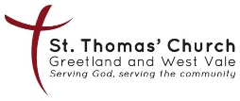
Lessons and Carols
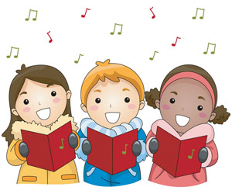
With Greetland Academy Singers

St Thomas’ Church Greetland
Sunday 14 December 2025
At 6:00pm

All very welcome
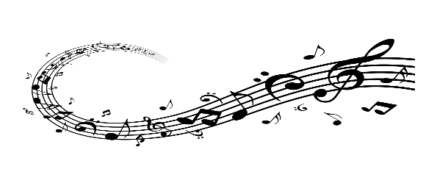
This Photo by Unknown Author is licensed under CC BY-NC

