TRIDENT
CONCERT BAND
ST MARY’S BRIGHSTONE
SATURDAY NOVEMBER 29th 7.30pm
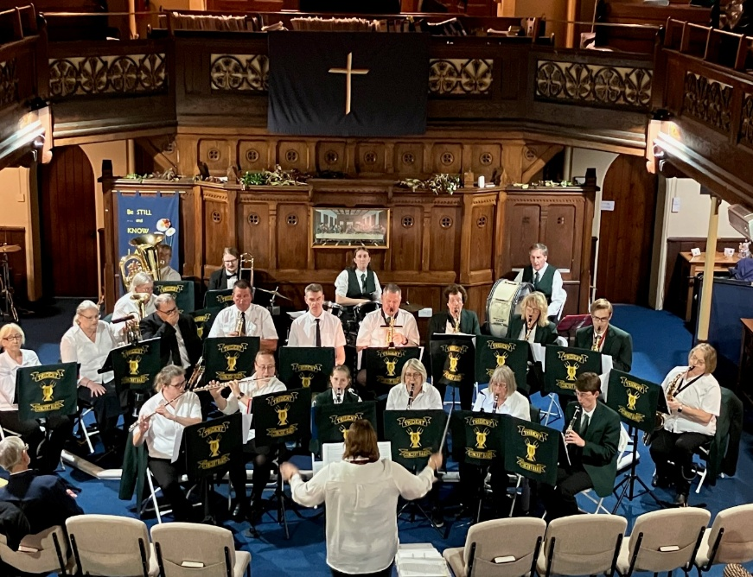
Playing festive tunes, also well known themes from musicals and films.
Refreshments
Free entry. Retiring collection

