Woodbridge
Group of Churches

Christmas Services 2025

in Brinkworth, Dauntsey, Garsdon,
Great Somerford, Lea,
Little Somerford

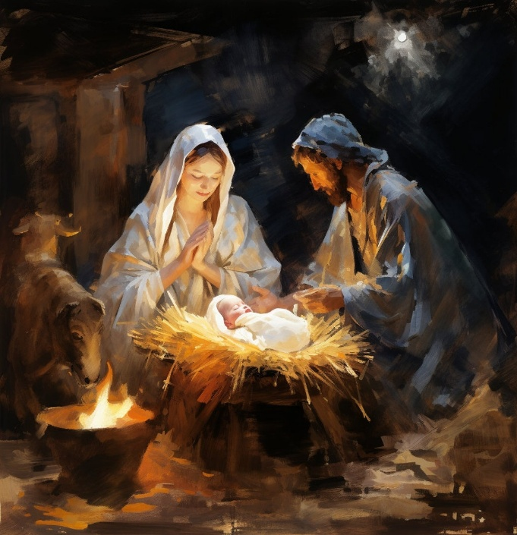

Happy Christmas

We warmly invite you to join us
as we worship Christ this Christmas

Sunday 7th December 2nd Sunday of Advent

- 11.00am Garsdon: Advent Lessons and Carols
- 3.30pm Great Somerford : Christingle - A family celebration of Jesus, the Light of the World.
- 4.00pm Brinkworth: Messy Church Christingle - A family celebration of Jesus, the Light of the World with crafts and refreshments.

Friday 12th December

- 6.00pm Brinkworth : Community Carols - with contributions by children from Brinkworth Earl Danby’s School and the Crown Singers, and festive refreshments provided by Brinkworth Heritage Society.

Sunday 14th December 3rd Sunday of Advent

- 11.00am Brinkworth: Advent Lessons and Carols
- 3.30pm Great Somerford: Lessons and Carols
- 5.00pm Lea: Christingle - A family celebration of Jesus, the Light of the World.

Sunday 21st December 4th Sunday of Advent

- 4.00pm Little Somerford: Lessons and Carols
- 5.00pm Lea: Lessons and Carols – A modern retelling of the story of God’s great salvation plan.
- 6.00pm Dauntsey: Lessons and Carols –Traditional carols & readings from the King James Bible.

Wednesday 24th December Christmas Eve
The Great Big Nativity : Three celebrations for all the family with the sights and sounds of the stable. Come dressed as a character and take part. Wellies & torches useful! No naked flames or candles please.
- 4.00pm Brinkworth, St. Michael and All Angels
- 4.00pm Great Somerford, The Volunteer Inn
- 4.30pm Lea, at Aquetong Farm, Cresswell Lane (Location: what3words.com/national.array.beyond). Please walk down from the village centre if possible, limited parking at the farm.
- 11.30pm Dauntsey: Midnight Communion - The First Communion of Christmas

Thursday 25th December Christmas Day

Bring one of your presents along and show us what is special to you. All services designed for the whole family.
- 10.00am Dauntsey: Family Worship
- 10.00am Great Somerford: Holy Communion - based on the Book of Common Prayer.
- 10.30am Brinkworth : Holy Communion
- 10.30am Garsdon: Family Communion
- 10.30am Little Somerford: Family Communion
- 11.00am Lea: Family Worship

Sunday 28th December 1st Sunday of Christmas
- 10.30am Great Somerford: Holy Communion



May the joy of the angels,
the eagerness of the shepherds,
the perseverance of the wise men,
the obedience of Joseph and Mary,
and the peace of the Christ child
be yours this Christmas time;
and the blessing of God Almighty,
the Father, the Son, and the Holy Spirit,
be among you and remain with you
this Christmas and throughout the coming year.


www.woodbridgegroup.co.uk

