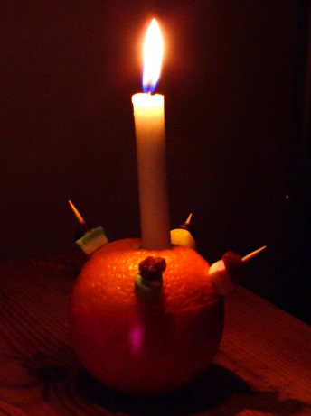
How to Make a Christingle
What Do Christingles Symbolise?
A Christingle starts with an orange, which is used to represent the whole world. The lit candle symbolises Jesus’s light in the world, this is to bring hope to all individuals who are living in darkness.
The sweets and dried fruit symbolise all God’s good gifts to us, and the red ribbon or tape represents the blood and love of Christ.

What Do You Need to Make a Christingle?
Christingles are made with various household items, making them incredibly simple. All you need is:
- An orange
- A taper candle
- A small piece of silver foil to catch the melting wax
- Ribbon or red tape to go around the orange
- 4 cocktail sticks
- Sweets and dried fruit (12 pieces per Christingle)

How to Create a Christingle
- Take an orange and wrap a piece of red ribbon or red sticky tape around the middle of it.
- On the top of your orange, cut a small cross.
- Place a small square piece of silver foil over the cross (around 6cm by 6cm). This will catch the dripping wax.
- Get a candle and wedge it into the cross of the orange.
- Add soft sweets and dried fruit such as raisins, cherries etc. onto four cocktail sticks.
- Insert the four cocktail sticks evenly into the orange around the base of the candle.
Store your Christingle upright in a cool, dry place. To keep it upright, take a thin slice off the bottom of the orange to create a flat base to balance on.

