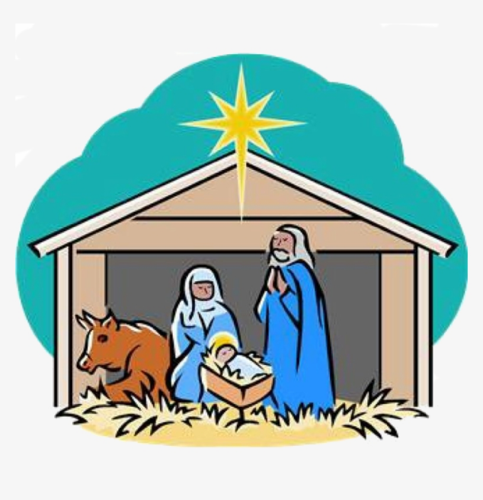
THURSDAY 25th DECEMBER
CHRISTMAS DAY
FAMILY COMMUNION with CAROLS at 10.30am

ST SAVIOUR’S CHURCH, WESTGATE
WEDNESDAY 24th DECEMBER
CHRISTMAS EVE
FIRST COMMUNION OF CHRISTMAS AT 11.30pm

