St. Mary’s, Great Parndon.
Advent and Christmas services 2025.

Please come and join us to celebrate Christ’s birth this Christmas season.

You will find us at St Mary’s Great Parndon, Peldon Road, Harlow. CM19 4HT

We look forward to meeting you here.

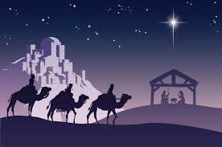

Date Time Service

Sunday 7th December 11:00am Christingle Service

Sunday 14th December 11:00am Holy Communion
4:00pm Carol Service

Sunday 22nd December 11:00am Holy Communion

Christmas Eve (Wednesday) 11:00pm Midnight Communion
Christmas Day (Thursday) 10:00am At St Peter’s, Roydon.

