
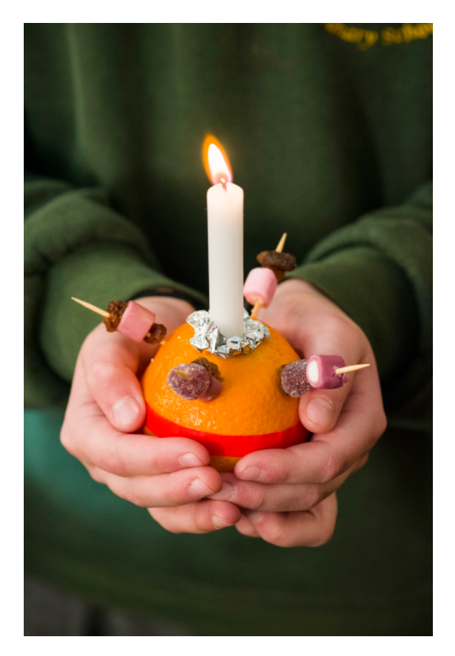

Christingle Workshop
& Crib Service

Sunday 14th December
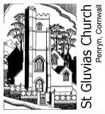
From 3pm

St Gluvias Church, Church Hill, Penryn

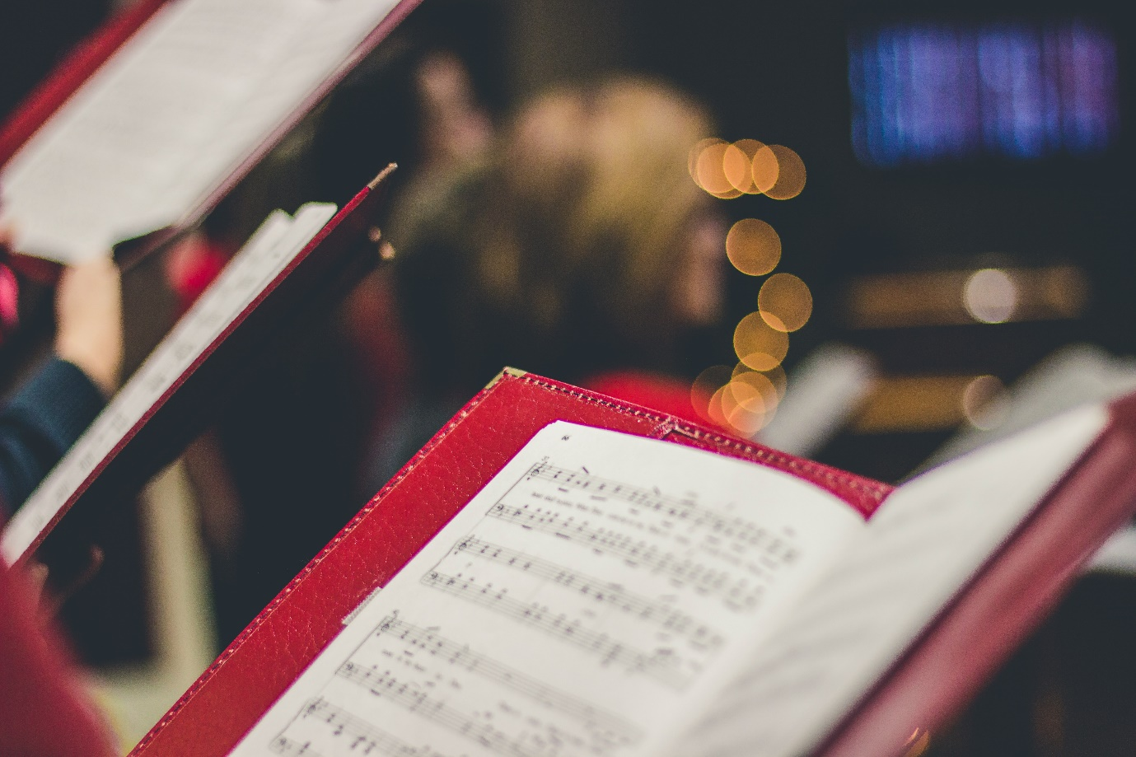

Carols
by Candlelight


Sunday 7th December
From 6pm

St Gluvias Church, Church Hill, Penryn

