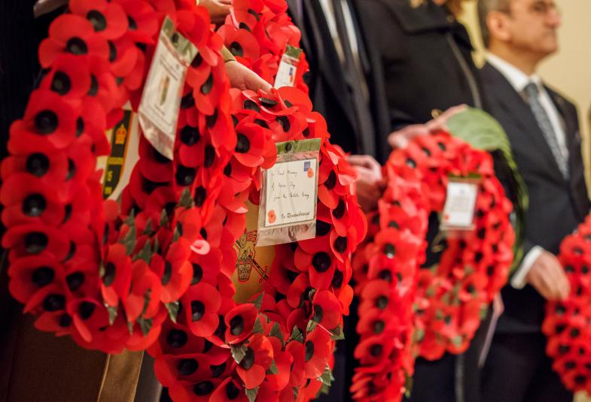

Remembrance Sunday
9th November 2025
10am

Led by The Rt. Rev’d Paul Davies, Bishop of Dorking

During the service, please join in with the words in bold type.
A brief welcome and notices.
If you are able, please stand as the procession enters.
Hymn
Please remain standing to sing the hymn, during which the standards are received.
1 I vow to thee, my country, all earthly things above,
entire and whole and perfect, the service of my love:
the love that asks no question, the love that stands the test,
that lays upon the altar the dearest and the best;
the love that never falters, the love that pays the price,
the love that makes undaunted the final sacrifice.

2 And there's another country I've heard of long ago,
most dear to them that love her, most great to them that know;
we may not count her armies, we may not see her King;
her fortress is a faithful heart, her pride is suffering;
and soul by soul and silently her shining bounds increase,
and her ways are ways of gentleness and all her paths are peace.
Cecil Arthur Spring-Rice (1859–1918)

Introduction
The Revd Dr Anthony Rustell
Rest eternal grant unto them, O Lord, and let light perpetual shine upon them.
We are here to worship God, whose purposes are good;
whose power sustains the world he has made;
who loves us, though we have failed in his service;
who gave Jesus Christ for the life of the world;
who by his Holy Spirit leads us in his way.
As we give thanks for his great works,
we remember those who have lived and died
in his service and in the service of others;
We pray for all who suffer through war and are in need;
we ask for his help and blessing that we may do his will,
and that the world may acknowledge him as Lord and King.
Act of Penitence
Let us confess to God the sins and shortcomings of the world;
After a short silence, we say together
All Most merciful God,
we confess that we have sinned.
We have acted wilfully,
vented our anger,
and sought revenge.
Curb our passions, we pray,
restrain our violence and hostility.
Give us the courage to speak out
in the face of injury and wrong.
And in your mercy,
restore and remake us,
that we may act justly, keep faith,
and walk in the way of your commandments,
in justice and in peace,
through Jesus Christ our Lord.
Amen.
Absolution
Almighty God, have mercy upon you,
pardon and deliver us from all your sins,
confirm and strengthen you in all goodness,
and keep you in eternal life;
through Jesus Christ our Lord.
All Amen
The Word
Please sit for our first reading
A reading from the Wisdom of Solomon, chapter 3: 1-9
(Councillor Simon Budd, Vice Chairman of the Council)
But the souls of the righteous are in the hand of God,
and no torment will ever touch them.
In the eyes of the foolish they seemed to have died,
and their departure was thought to be a disaster
and their going from us to be their destruction,
but they are at peace.
For though in the sight of others they were punished,
their hope is full of immortality.
Having been disciplined a little,
they will receive great good,
because God tested them
and found them worthy of himself;
like gold in the furnace he tried them,
and like a sacrificial burnt offering he accepted them.
In the time of their visitation they will shine forth
and will run like sparks through the stubble.
They will govern nations and rule over peoples,
and the Lord will reign over them forever.
Those who trust in him will understand truth,
and the faithful will abide with him in love,
because grace and mercy are upon his holy ones,
and he watches over his elect.
This is the Word of the Lord.
All Thanks be to God.

Please stand to sing the hymn
1 And did those feet in ancient time
walk upon England's mountains green?
And was the holy Lamb of God
on England's pleasant pastures seen?
And did the countenance divine
shine forth upon our clouded hills?
And was Jerusalem builded here
among these dark satanic mills?

2 Bring me my bow of burning gold!
Bring me my arrows of desire!
Bring me my spear! O clouds, unfold!
Bring me my chariot of fire!
I will not cease from mental fight,
nor shall my sword sleep in my hand,
till we have built Jerusalem
in England's green and pleasant land.
William Blake (1757–1827)

Please sit for our second reading
A reading from Revelation, chapter 21: 1-7
(Mr David Collett, Group Lead Volunteer 1st Dorking Scout Group)
Then I saw a new heaven and a new earth;
for the first heaven and the first earth had passed away, and the sea was no more. And I saw the holy city,
the new Jerusalem, coming down out of heaven from God, prepared as a bride adorned for her husband.
And I heard a loud voice from the throne saying,
‘See, the home of God is among mortals.
He will dwell with them; they will be his peoples,
and God himself will be with them;
he will wipe every tear from their eyes.
Death will be no more; mourning and crying and pain
will be no more, for the first things have passed away.’
And the one who was seated on the throne said,
‘See, I am making all things new.’
Also he said,
‘Write this, for these words are trustworthy and true.’ Then he said to me, ‘It is done!
I am the Alpha and the Omega, the beginning and the end. To the thirsty I will give water as a gift from the spring of the water of life.
Those who conquer will inherit these things, and I will be their God and they will be my children.’
This is the Word of the Lord.
All Thanks be to God.
Address
The Rt. Revd Paul Davies, Bishop of Dorking
Hymn
Please stand to sing the hymn, during which a collection will be taken for the Royal British Legion.
1 Eternal Father, strong to save,
whose arm doth bind the restless wave,
who bidd'st the mighty ocean deep
its own appointed limits keep:
O hear us when we cry to thee
for those in peril on the sea.

2 O Saviour whose almighty word
the winds and waves submissive heard,
who walkedst on the foaming deep,
and calm amid its rage didst sleep:
O hear us when we cry to thee
for those in peril on the sea.

3 O sacred Spirit, who didst brood
upon the chaos dark and rude,
who bad'st its angry tumult cease,
and gavest light and life and peace:
O hear us when we cry to thee
for those in peril on the sea.

4 O Trinity of love and power,
our brethren shield in danger's hour;
from rock and tempest, fire and foe,
protect them whereso'er they go:
and ever let there rise to thee
glad hymns of praise from land and sea.
William Whiting (1825–1878)

Prayers
Canon Peter Bruinvels CC
Please kneel or sit for our prayers ending with
O God of truth and justice,
we hold before you those whose memory we cherish,
and those whose names we will never know.
Help us to lift our eyes above the torment
of this broken world, and grant us the grace
to pray for those who wish us harm.
As we honour the past,
may we put our faith in your future;
for you are the source of life and hope,
now and for ever.
All Amen.
All Our Father, who art in heaven,
hallowed be thy name;
thy kingdom come;
thy will be done;
on earth as it is in heaven.
Give us this day our daily bread.
And forgive us our trespasses,
as we forgive those who trespass against us.
And lead us not into temptation;
but deliver us from evil.
For thine is the kingdom,
the power and the glory,
for ever and ever. Amen.
Hymn
Please stand to sing the hymn, during which the standards will be returned
1 Guide me, O thou great Redeemer,
pilgrim through this barren land;
I am weak, but thou art mighty;
hold me with thy powerful hand:
Bread of heaven,
feed me now and evermore.

2 Open now the crystal fountain
whence the healing stream doth flow;
let the fiery cloudy pillar
lead me all my journey through:
strong deliverer,
be thou still my strength and shield.

3 When I tread the verge of Jordan,
bid my anxious fears subside;
death of death, and hell's destruction,
land me safe on Canaan's side:
songs and praises
I will ever give to thee.
Arglwydd, arwain trwy'r anialwch
William Williams (1717–1791)
translated by Peter Williams (1727–1796)

The Exhortation: Maj. (Ret’d) Elizabeth J. Viner, ARRC, QARANC
They shall grow not old as we that are left grow old,
age shall not weary them, nor the years condemn;
at the going down of the sun, and in the morning,
we will remember them.
All We will remember them.

The Last Post
Silence is kept for two minutes
Reveille
Act of Commitment
The Revd Gerard Mee
Let us pledge ourselves anew to the service of God
and our fellow men and women:
that we may help, encourage, and comfort others,
and support those working for the relief of the needy
and for the peace and welfare of the nations.
All Lord God our Father,
we pledge ourselves to serve you and all people,
in the cause of peace,
for the relief of want and suffering,
and for the praise of your name.
Guide us by your Spirit;
give us wisdom; give us courage; give us hope;
and keep us faithful now and always.
Amen.
Blessing
The Rt. Revd Paul Davies, Bishop of Dorking
May the God of all power and might
make you strong in faith and love,
defend you on every side,
and guide you in truth and peace;
and the blessing of God almighty,
the Father, the Son, and the Holy Spirit,
be among you and remain with you always.
All Amen.

The National Anthem
God save our gracious King,
Long live our noble King,
God save the King.
Send him victorious,
Happy and glorious,
Long to reign over us,
God save the King.
Words: Anon.
Music: Thesaurus Musicus (c. 1743)
Please remain in your seats to allow the uniformed organisations, choir, clergy and councillors to leave first.
The choir and clergy will then process out of the church followed by the distinguished guests. They will make their way in procession to the War Memorial on South Street for the Act of Remembrance.
Please do join us there.



Common Worship: Times and Seasons,
material from which is included in this service,
is copyright © The Archbishops’ Council 2006
Hymns covered by Christian Copyright Licensing (Europe) Ltd
are reproduced under CCL no. 895472

