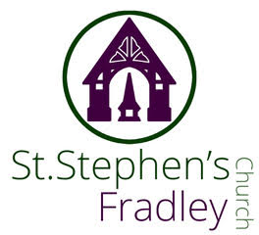
Heritage Concert by U3A Recorder Group

Music for the Season
Thursday 4th December
7.30pm
Light refreshments will be served after the concert
Free Event
Donations welcomed

