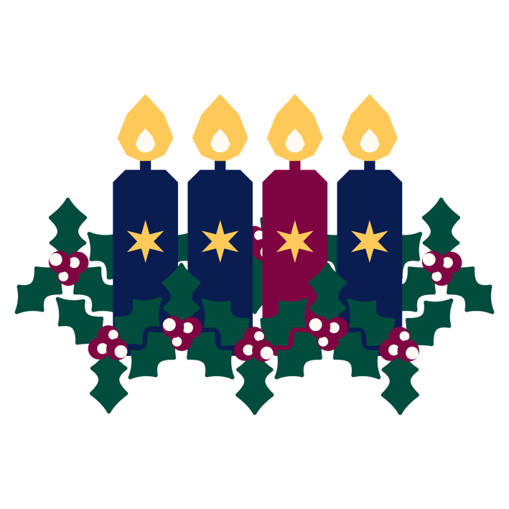

ST MARGARET’S CHURCH DRAYTON
CHRISTMAS SERVICES

30TH NOVEMBER 10.30AM HOLY COMMUNION
FOR ADVENT SUNDAY

21ST DECEMBER 6.30PM CAROLS BY CANDLELIGHT
With Drayton School Choir

24TH DECEMBER CHRISTMAS EVE
CHRISTINGLE SERVICE 4.00PM
BETHLEHEM TIME HOLY COMMUNION 9.30PM

25TH DECEMBER CHRISTMAS DAY
COMMUNION AND CAROLS 9.30AM

