Readings
Luke 21: 5-19

Today’s Service
Revd Stephen Coe will be leading our All Age Service. Refreshments will be served after the service.

Collect
Heavenly Father,
whose blessed Son was revealed
to destroy the works of the devil
and to make us the children of God and heirs of eternal life:
grant that we, having this hope,
may purify ourselves even as he is pure;
that when he shall appear in power and great glory
we may be made like him
in his eternal and glorious kingdom;
where he is alive and reigns with you,
in the unity of the Holy Spirit,
one God, now and for ever. Amen.

Next Sunday
Revd Maggie Crosbie will be presiding at our service of Holy Communion at 10.00 am, with Revd Tony Rogerson preaching.

Let us pray for: Brian Cross who is terminally ill but now back at home, and for Jenny, Caroline and the family as they continue to care for him.

St Peter’s Church Wootton

Sunday 16th November 2025

2nd Sunday before Advent

All Age Service

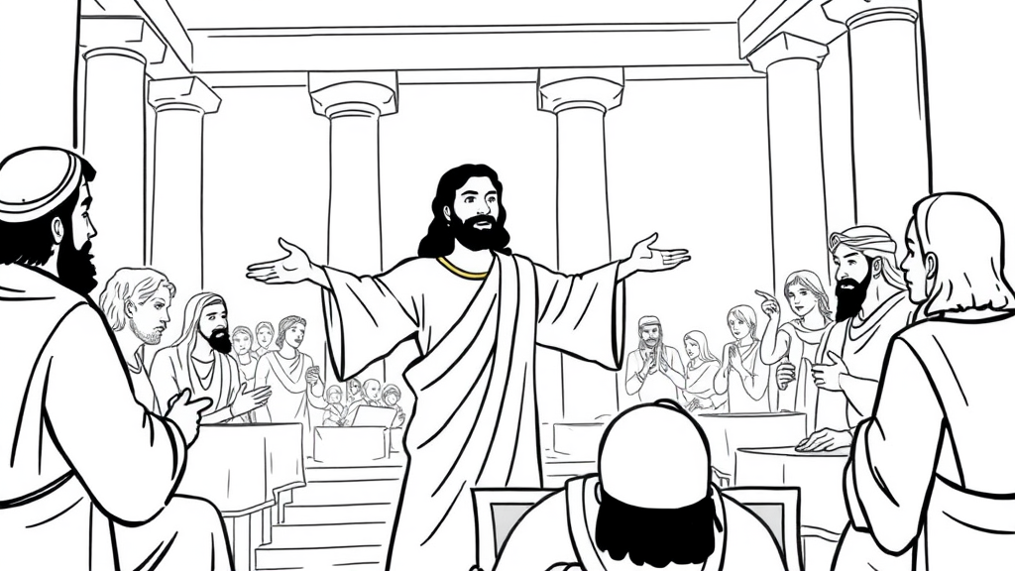

“Not one stone will be left on another”
(Luke 21:6)

St Peter’s Wootton
A vibrant, growing church
at the heart of the community
spreading the love, joy and peace of Jesus to all

Advent Course
We are planning to run an Advent course on each of the 4 Sundays of Advent at 4.00 pm either in the vicarage or in church (Sunday 30th November, Sunday 7th, 14th and 21st December). Each session will last about 1 hour including refreshments and will be based around the 4 candles of Advent representing hope, peace, joy and love as we anticipate the birth of Jesus. Please speak to Maggie if you would like to attend or would like further information.

Prayer meeting
We will continue to meet fortnightly on a Friday at 12.00 for half an hour to pray for our church and parish. We will next meet on Friday 28th November at 12.00. Please join us if you are free.

FUTURE SERVICES
Wednesday 19th November – Holy Communion at 10.00 am
Sunday 23rd November – Holy Communion at 10.00 am – Revd Maggie Crosbie
Sunday 30th November – Holy Communion at 10.00 am – Revd Maggie Crosbie (we will be joined by our friends from St Mary Magdalene Shippon for this benefice service).
Wednesday 3rd December – Holy Communion at 10.00 am
Sunday 7th December – Morning Prayer and Praise at 10.00 am – Dr Shirley Northover
Sunday 14th December – Holy Communion at 10.00 am – Revd Maggie Crosbie
Wednesday 17th December – Holy Communion at 10.00 am

Sunday School next meets on Sunday 7th December in the Parish room.

Our next Open Church is on Saturday 22nd November between 10.00 and 12.00 - do drop in for a bacon roll, tea, coffee and biscuits and the opportunity for a friendly chat surrounded by the peace and beauty of our ancient church.

Further details are available at www.woottonchurch.co.uk
You can contact us by email at: woottonvicarage@btinternet.com
or by telephone on 01865 735661. Maggie can be contacted directly at: revmaggiecrosbie@gmail.com

