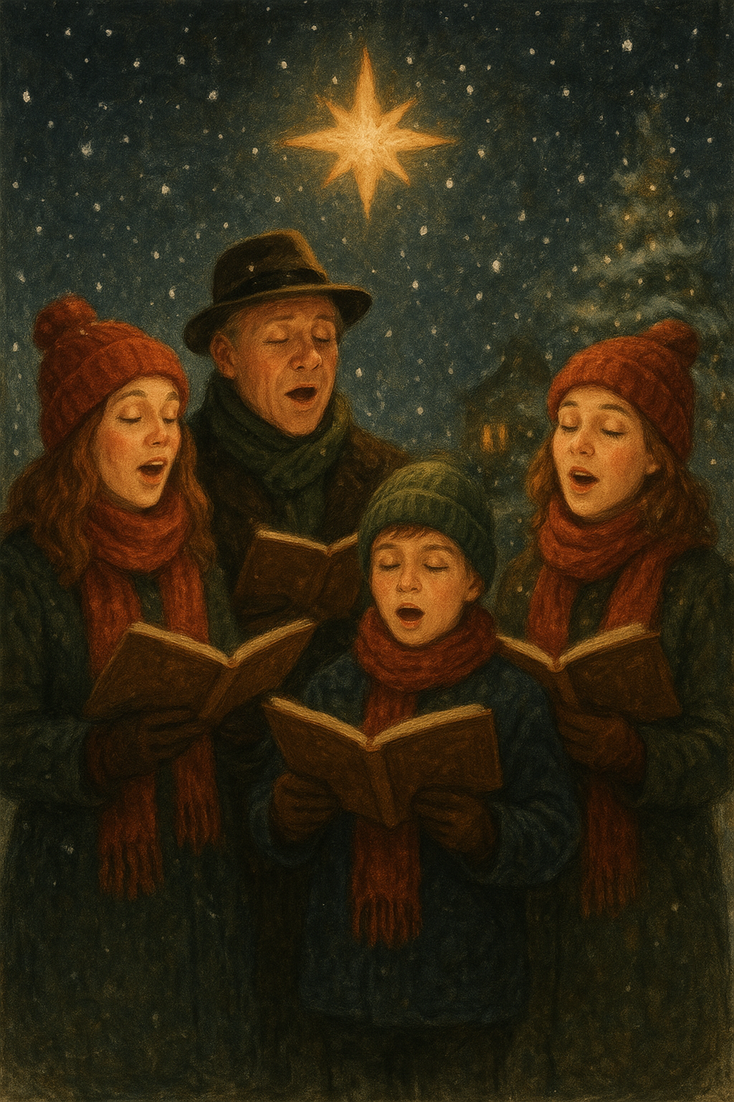
Froxfield Choir this Christmas
Also for carols at the No Name Pub on Thursday 18th December at 8pm
Come and join Froxfield Choir at Holy Trinity, Privett for the service of Nine Lessons and Carols on Saturday 20th December at 6:30pm

