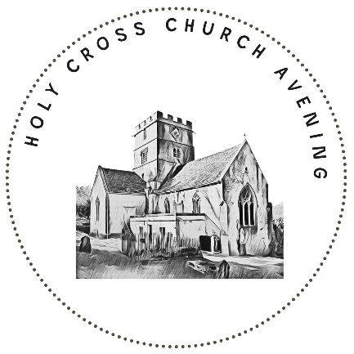



Iona Abbey
Evening Prayer Liturgy

The people gather
The minister welcomes the people and introduces the service.
In the beginning,
when it was very dark,
God said, ‘Let there be light.’
All And there was light.
A candle is lit
In the beginning,
when it was very quiet,
the Word was with God.
All And what God was, the Word was.
An open Bible may be placed centrally
When the time was right,
God sent his Son.
All He came among us;
he was one of us.
A cross may be placed centrally

Opening Responses
This is the time
when light fades
and shadows lengthen
and sounds are subdued –
all as God intended.
All Amen.
This is the time
when bodies relax,
minds unwind,
and tiredness comes –
all as God intended.
All Amen.
This is the time
when others greet the morning
while we meet the night,
and the world continues to sing,
in all the accents of creation,
a love-song to its Maker.
All Blessed by God’s name.

A piece of music may be played, or a song may be sung. Otherwise, we keep a short time of silence as we recognise God’s presence with us.

Prayer
Come, brother Jesus, be our guest,
stay with us for day is ending.
Bring to this place your poverty,
All for then we shall be rich.
Bring to this place your pain,
All that in sharing it, we may also share your joy.
Bring to this place your understanding of us,
All that we may be freed to learn more of you.
Bring to this place your Holy Spirit,
All that we and all things might be made new.
With friend, with stranger,
with the unknown and well-known ones
be among us tonight,
All for the doors of this house are open,
and the doors of our hearts we leave ajar.

We listen
In the world many things happen at night:
people travel, people meet,
people have secret conversations,
people lie awake restless,
people sleep through exhaustion.
And this has always been so;
holy books bear witness to it.
So let us hear a story from the Bible.

We hear words from Scripture.
At the end the reader says
For the Word of the Lord,
All thanks be to God.
Reflection
A reflection may be given, following which we keep a short period of silence.

We respond
Night prayer
These or other prayers of intercession may be used.
What if the darkness covers us
and the day around us turns to night?
Darkness is not too dark for God,
to whom dark and light are one.
Let us pray.
You never sleep, God.
You are always awake, always watching,
always willing the world and its people
to turn in the right direction.
So tonight, will you comfort those who cannot sleep
because of illness,
or worry,
or fear;
or for reasons they cannot understand.
(pause)
God be near them.
All God be near them.

And tonight, will you be close to those who wait
patiently or impatiently
for a birth
or a death,
for a visit,
or for the pieces of their life’s jigsaw to fit together.
(pause)
God be near them.
All God be near them.

And tonight, will you be close to those who wonder,
who look for inspiration,
who long to be with the one or the ones they love,
who hope to recognise the right time
when they can say ‘I’m sorry,’
or ‘I love you,’
or even ‘Enough is enough.’.
(pause)
God be near them.
All God be near them.

And God, listen to us
as we share with you
whatever joys or sorrows,
discoveries or questions
we will take with us into the night.
(pause)
God be near us.
All God be near us.
Into your hands we commit ourselves –
our souls, our bodies, our minds, our futures –
for all things come from you
and are best kept in your care.
All Amen.

A piece of music may be played, or a song may be sung. Otherwise, we keep a short time of silence as we recognise God’s presence with us.

We are sent out
Closing Responses

I lie down with God,
All and God lies down with me.
I lie down with Christ,
All and Christ lies down with me.
I lie down with the Spirit,
All and the Spirit lies down with me.
God and Christ and the Spirit –
All all three with me.

For the day now done
All thanks be to God.
For the rest before us
All thanks be to God.
Because God never sleeps
so that we can
All thanks be to God.
But before the day is done,
let God’s holy name be praised;
and let God’s people say Amen.
All Amen.

Blessing
See that you be at peace among yourselves, my children,
and love one another.
Follow the example of the wise and good
and God will comfort you and help you,
both in this world and in the world which is to come.
+ In the name of the Father, and of the Son,
and of the Holy Spirit.
All Amen.

The candles are extinguished, and we leave quietly.

Material in this service is taken from ‘Evening Liturgy’
From the book Iona Abbey Worship Book © The Iona Community 2016

