1

Carols on the Green
Sunday 25TH December
At 3.30 pm


Organised by
St Michael’s church,
Carleton.

The Angel Gabriel from Heaven Came

The angel Gabriel from heaven came,
his wings as drifted snow, his eyes as flame;
"All hail," said he to meek and lowly Mary,
"most highly favored maiden." Gloria!

"I come from heav'n to tell the Lord's decree:
a blessed virgin mother you shall be.
Your Son shall be Immanuel, by seers foretold,
most highly favored maiden." Gloria!

Then gentle Mary meekly bowed her head;
"To me be as it pleases God," she said.
"My soul shall laud and magnify his holy name."
Most highly favored maiden, Gloria!

Of her, Immanuel, the Christ, was born
In Bethlehem, all on a Christmas morn,
and Christian folk throughout the world will ever say,
"Most highly favored maiden." Gloria!

Little Donkey

Little donkey, little donkey on the dusty road
Got to keep on plodding onwards with your precious load
Been a long time, little donkey, through the winter’s night
Don’t give up now, little donkey,
Bethlehem’s in sight

Ring out those bells tonight
Bethlehem, Bethlehem
Follow that star tonight
Bethlehem, Bethlehem
Little donkey, little donkey, had a heavy day
Little donkey, carry Mary safely on her way

Little donkey, little donkey, journey's end is near
There are wisemen waiting for a sign to bring them here
Do not falter little donkey, there's a star ahead
It will guide you, little donkey, to a cattle shed

Ring out those bells tonight
Bethlehem, Bethlehem
Follow that star tonight
Bethlehem, Bethlehem
Little donkey, little donkey, had a heavy day
Little donkey, carry Mary, safely on her way
Little donkey, carry Mary, safely on her way

Lyrics by Eric Boswell

O Little Town of Bethlehem

O little town of Bethlehem,
How still we see thee lie!
Above thy deep and dreamless sleep
The silent stars go by;
Yet in the dark street shineth
The everlasting Light;
The hopes and fears of all the years
Are met in thee tonight.

For Christ is born of Mary,
And fathered all above,
While mortals sleep, the angels keep
Their watch of wondering love.
O morning stars, together
Proclaim the holy birth
And praises sing to God, the King,
And peace to men on earth.
How silently, how silently,
The wondrous Gift is given!

So God imparts to human hearts
The blessings of His heaven.
No ear may hear His coming,
But in this world of sin,
Where meek souls will receive Him still,
The dear Christ enters in.

O holy Child of Bethlehem,
Descend to us, we pray;
Cast out our sin and enter in,
Be born in us today.
We hear the Christmas angels
The great glad tidings tell:
Oh, come to us, abide with us,
Our Lord Immanuel!
Lyrics by Phil [s Brooks 1868

Away in a Manger

Away in a manger, no crib for a bed,
The little Lord Jesus laid down his sweet head.
The stars in the sky looked down where he lay,
The little Lord Jesus asleep in the hay.
The cattle are lowing, the baby awakes,
But little Lord Jesus no crying he makes.
I love Thee, Lord Jesus, look down from the sky
And stay by my cradle til morning is nigh.
Be near me, Lord Jesus, I ask Thee to stay
Close by me forever, and love me, I pray.
Bless all the dear children in thy tender care,
And take us to heaven, to live with Thee there.
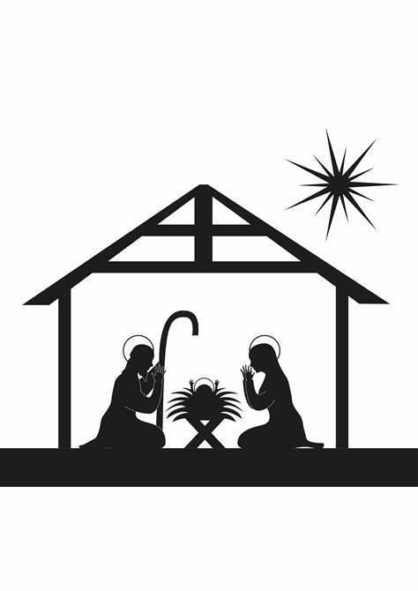Lyrics traditional

It was on a starry night
It was on a starry night,
when the hills were bright.
Earth lay sleeping, sleeping calm and still.
Then in a cattle shed,
in a manger bed,
a boy was born, King of all the world.

And all the angels sang for him,
the bells of heaven rang for him
for a boy was born, King of all the world.
And all the angels sang for him,
the bells of heaven rang for him,
for a boy was born, King of all the world.

Soon the shepherds came that way,
where the baby lay,
and were kneeling, kneeling by his side.
And their hearts believed again,
for the peace of men,
for a boy was born, King of all the world.

And all the angels sang for him,
the bells of heaven rang for him
for a boy was born, King of all the world.
And all the angels sang for him,
the bells of heaven rang for him,
for a boy was born, King of all the world.

Lyrics by Joy Webb

We Three Kings
We three kings of Orient are
Bearing gifts we traverse afar
Field and fountain, moor and mountain
Following yonder star

Oh, oh, star of wonder, star of night
Star with royal beauty bright
Westward leading, still proceeding
Guide us to thy perfect light

Born a king on Bethlehem plain
Gold I bring to crown Him again
King forever, ceasing never
Over us all to reign

Oh, oh, star of wonder, star of night
Star with royal beauty bright
Westward leading, still proceeding
Guide us to thy perfect light

Glorious now, behold Him arise
King and God and sacrifice
Heaven sings Alleluia
Alleluia, the earth replies

Oh, oh, star of wonder, star of night
Star with royal beauty bright
Westward leading, still proceeding
Guide us to thy perfect light

Lyrics by John H Hopkins

Hark! The Herald Angels Sing

Hark the herald angels sing
Glory to the newborn King
Peace on earth and mercy mild
God and sinners reconciled
Joyful, all ye nations rise
Join the triumph of the skies
With angelic host proclaim
Christ is born in Bethlehem
Hark the herald angels sing
Glory to the newborn King

Christ by highest Heaven adored
Christ the everlasting Lord
Late in time behold Him come
Offspring of a virgin's womb
Veiled in flesh the Godhead see
Hail the incarnate deity
Pleased as man with man to dwell
Jesus our Emmanuel
Hark the herald angels sing
Glory to the newborn King

Lyrics traditional

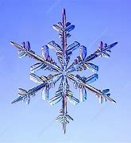
In The Bleak Midwinter"
In the bleak midwinter, frosty wind made moan,
Earth stood hard as iron, water like a stone;
Snow had fallen, snow on snow, snow on snow,
In the bleak midwinter, long ago.

Our God, heaven cannot hold Him, nor earth sustain; Heaven and earth shall flee away when He comes to reign.
In the bleak midwinter a stable place sufficed
The Lord God Almighty, Jesus Christ.

Angels and archangels may have gathered there,
Cherubim and seraphim thronged the air;
But His mother only, in her maiden bliss,
Worshipped the beloved with a kiss.

What can I give Him, poor as I am?
If I were a shepherd, I would bring a lamb;
If I were a Wise Man, I would do my part;
Yet what I can I give Him: give my heart.

Lyrics by Christina Rossetti

Silent Night
Silent night! Holy night!
All is calm, all is bright
round yon Virgin Mother and Child,
Holy infant so tender and mild,
sleep in Heavenly peace!
sleep in Heavenly peace!

Silent night! Holy night!
Shepherds quake at the sight;
glories stream from Heaven afar,
Heavenly hosts sing Alleluia,
Christ, the Saviour, is born!
Christ, the Saviour, is born!

Silent night! Holy night!
Son of God, Love’s pure light
radiant, beams from Thy Holy face,
with the dawn of redeeming grace,
Jesus, Lord at Thy birth,
Jesus, Lord at Thy birth.

Lyrics by John Freeman Young

O Come, all ye faithful

O come, all ye faithful,
joyful and triumphant!
O come ye, O come ye to Bethlehem!
Come and behold him,
born the King of angels.

O come, let us adore him,
O come, let us adore him,
O come, let us adore him,
Christ the Lord!

God from true God, and
Light from Light eternal,
born of a virgin, to earth he comes!
Only-begotten Son of God the Father:

O come, let us adore him,
O come, let us adore him,
O come, let us adore him,
Christ the Lord!

Sing, choirs of angels,
sing in exultation,
sing, all ye citizens of heav’n above!
Glory to God, all glory in the highest

O come, let us adore him,
O come, let us adore him,
O come, let us adore him,
Christ the Lord! Lyrics by John Francis Wade
Once in Royal David’s city
Once in Royal David’s city
Stood a lowly cattle shed.
Where a mother laid her baby
In a manger for His bed.
Mary was that mother mild,
Jesus Christ that little child.

He came down to earth from Heaven,
Who is God and Lord of all.
And his shelter was a stable,
And his cradle was a stall.
With the poor and mean and lowly,
Lived on earth our Saviour Holy.

And our eyes at last shall see Him
Through His own redeeming love,
For that child so dear and gentle
Is our Lord in Heaven above;
And He leads His children on
To the place where He is gone.

Not in that poor, lowly stable,
With the oxen standing by,
We shall see Him; but in Heaven,
Set at God’s right hand on high,
When, like stars, His children crowned
All in white, shall wait around.
Lyrics by Cecil Frances Alexander

The Holly and the Ivy
The holly and the ivy,
When they are both full grown,
Of all trees that are in the wood,
The holly bears the crown

O, the rising of the sun,
And the running of the deer
The playing of the merry organ,
Sweet singing in the choir.

The holly bears a blossom,
As white as lily flow'are,
And Mary bore sweet Jesus Christ,
To be our dear Saviour

O, the rising of the sun,
And the running of the deer
The playing of the merry organ,
Sweet singing in the choir.

The holly bears a berry,
As red as any blood,
And Mary bore sweet Jesus Christ,
To do poor sinners good

O, the rising of the sun,
And the running of the deer
The playing of the merry organ,
Sweet singing in the choir.

The holly bears a prickle,
As sharp as any thorn,
And Mary bore sweet Jesus Christ,
On Christmas Day in the morn

O, the rising of the sun,
And the running of the deer
The playing of the merry organ,
Sweet singing in the choir.

The holly bears a bark,
As bitter as the gall,
And Mary bore sweet Jesus Christ,
For to redeem us all

O, the rising of the sun,
And the running of the deer
The playing of the merry organ,
Sweet singing in the choir.

The holly and the ivy,
When they are both full grown,
Of all trees that are in the wood,
The holly bears the crown

O, the rising of the sun,
And the running of the deer
The playing of the merry organ,
Sweet singing in the choir.

Lyrics by Cecil Sharpe

While Shepherds Watched

While shepherds watched their flocks by night,
All seated on the ground,
The angel of the Lord came down,
And glory shone around.

“Fear not!” said he, for mighty dread
Had seized their troubled mind;
“Glad tidings of great joy I bring
To you and all mankind.

“To you, in David’s town, this day
Is born of David’s line
A Savior, who is Christ the Lord,
And this shall be the sign:

“All glory be to God on high
And to the Earth be peace;
Good will henceforth from heav’n to men
Begin and never cease!”
Lyrics by Nahum Tate

Ding dong! merrily on high
Ding dong! merrily on high
In heav’n the bells are ringing:
Ding dong! verily the sky
Is riv’n with Angel singing.

Gloria,
Hosanna in excelsis!

E’en so here below, below,
Let steeple bells be swungen,
And “Io, io, io!”
By priest and people sungen.

Gloria,
Hosanna in excelsis!

Pray you, dutifully prime
Your matin chime, ye ringers;
May you beautifully rime
Your evetime song, ye singers.

Gloria,
Hosanna in excelsis!
Lyrics by George Ratcliffe Woodward

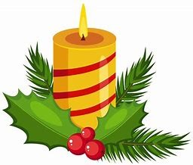

Wishing you a very happy Christmas,
and a peaceful New Year
From all at St Michael’s Church, Carleton.
We would be very pleased if you would join us for our Carol Service in St Michael’s Church, this evening at 6.00 pm followed by refreshments in Carleton Community Centre.

Our Christmas Eucharist Services are as follows:
24th December at 11:30pm - The Midnight Service – St Michael’s Carleton
25th December at 10:00am - The Christmas Day Service – St Stephen’s, East Hardwick

