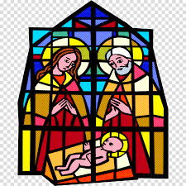

ADVENT & CHRISTMAS 2025

Friday 5th December
Christmas Tree Festival St. Peter’s, Sharnbrook 3:30pm – 8:30pm
Saturday 6th December
Christmas Tree Festival St. Peter’s, Sharnbrook 11:00am-3.30pm
Christingle Service St. Peter’s, Sharnbrook 4.00pm

Sunday 7th December
Advent & Christmas Concer t
Ouse Valley Singers St. Peter’s, Sharnbrook 3.00pm

Sunday 14th December
Nine Lessons & Carols St Mary’s, Felmersham 6.00pm
Sunday 21st December
Nine Lessons & Carols All Saints’, Souldrop 6.00pm

Wednesday 24th December: Christmas Eve
Crib Service St Peter’s, Sharnbrook 3.00pm
Crib Service St Mary’s, Felmersham 3.00pm
Nine Lessons & Carols St Peter’s, Sharnbrook 6.00pm
Midnight Mass St Peter’s, Sharnbrook 11.30pm
Midnight Mass St Mary’s, Felmersham 11.30pm

Thursday 25th December: Christmas Day
Benefice Christmas
Communion St Peter’s, Sharnbrook 10.30am

All are welcome to celebrate with us!

The United Benefice of Sharnbrook, Felmersham, Radwell & Knotting with Souldrop
