**St Ken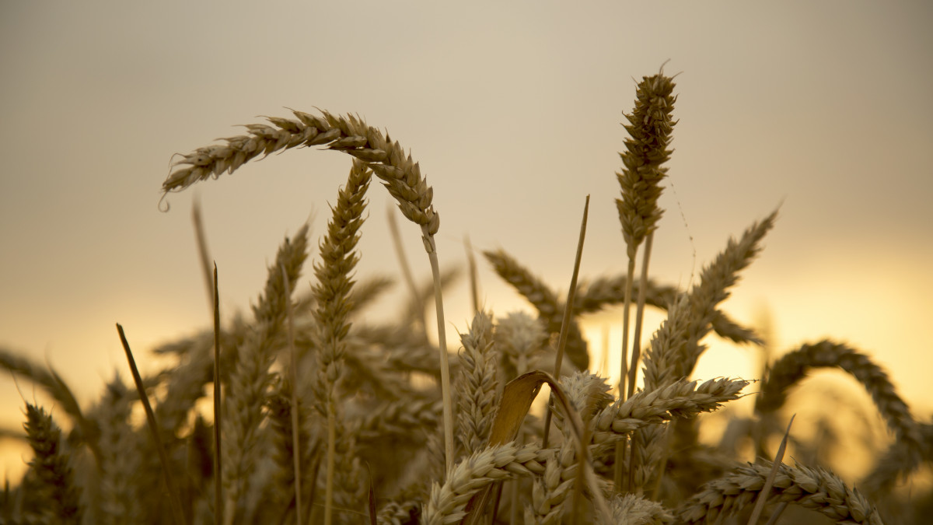elm’s Harvest Tea**

**Friday 10th October 5.00 – 6.30**

**At Clifton Upon Teme Village Hall**

**Come and celebrate the work of local farmers.**

**Talk: From a local farmer**

**Tea, sandwiches, cake etc.**

**Raffle, Vegetable creature competition, colouring**

**No charge but any money donations will be used to cover costs and donate to Worcester Food Bank.**