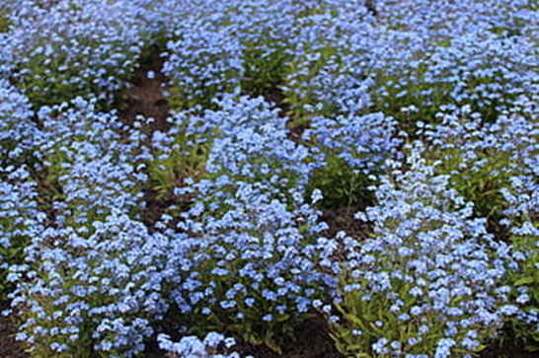
with Holy Communion
Remembering
Service

Farnham Church
Sunday 2 November
at 10.30am
Be they members of the family or part of our
communities, we all have people who remain in
our hearts long after they have passed away.
However long ago someone dear to you died, you will be welcome at this service, when we will remember those dear to us and candles will be lit for them.

Refreshments afterwards

