St. Stephen’s Church
Fradley
Remembrance Sunday
9th November

10.30am
Eucharist
with
Act of Remembrance
6pm
Remembrance Service
with
The Uniformed Organisations

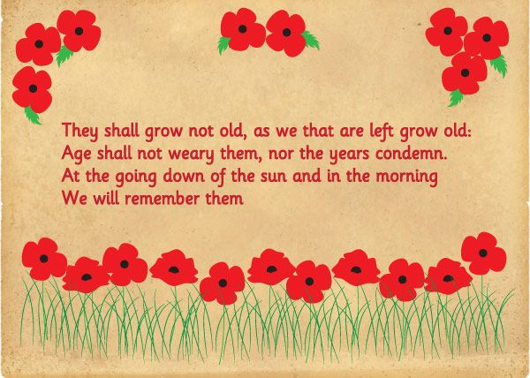

“We will remember them”

