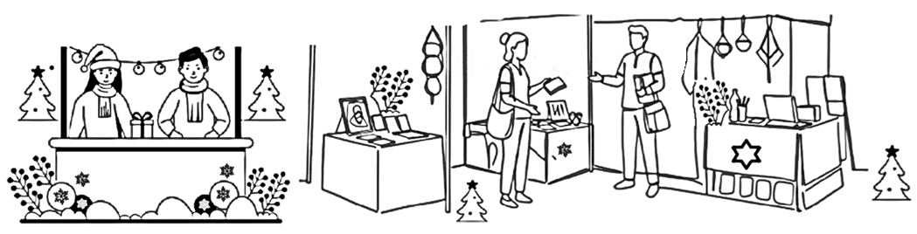
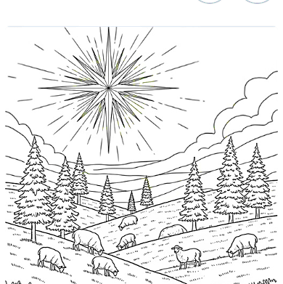
Saturday 22 November,
10 till 12:30
lots of crafts, stalls, cakes,
Christmas food, raffle, games, etc....
HAUGHLEY CHURCH
CHRISTMAS FAIR

