
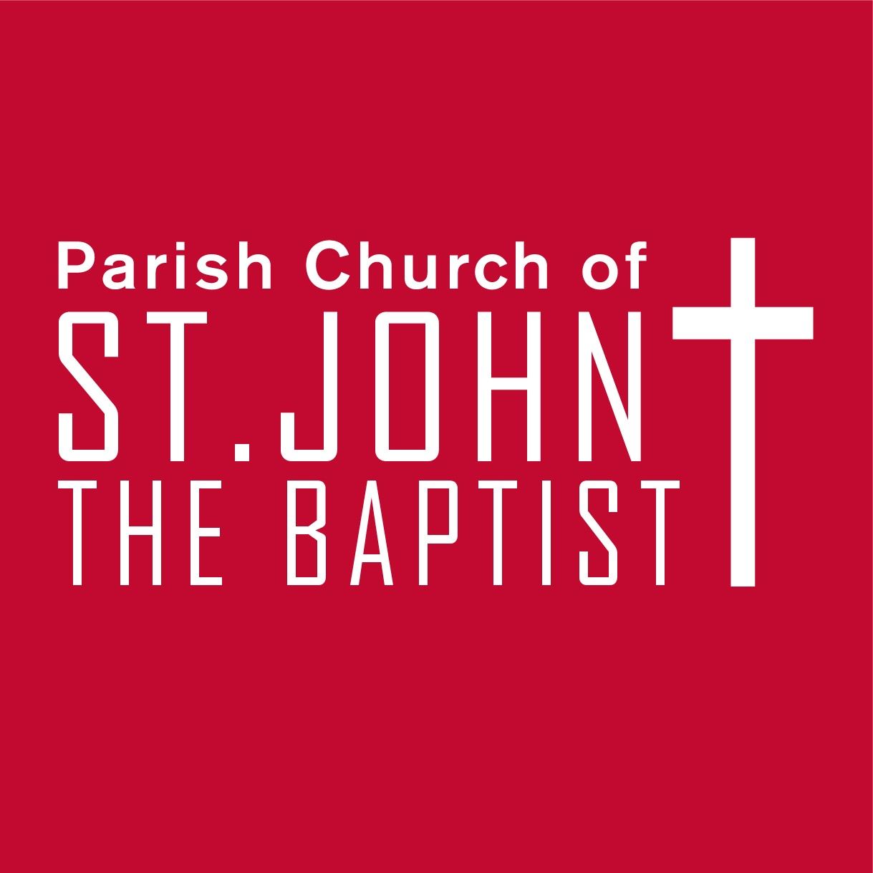
Monday 22nd December 2025 at 5.00pm in the Parish Church of St John the Baptist, Royston.

Service
Blue Christmas

Christmas time is hard for those whose hearts are hurting. For those of us experiencing loneliness, sadness and loss, Christmas can be difficult.
But we are not alone.
Please join us for a simple service of music, readings, and a reflection of God’s hope for us and presence with us in feeling what we feel.
All are welcome.

Royston.

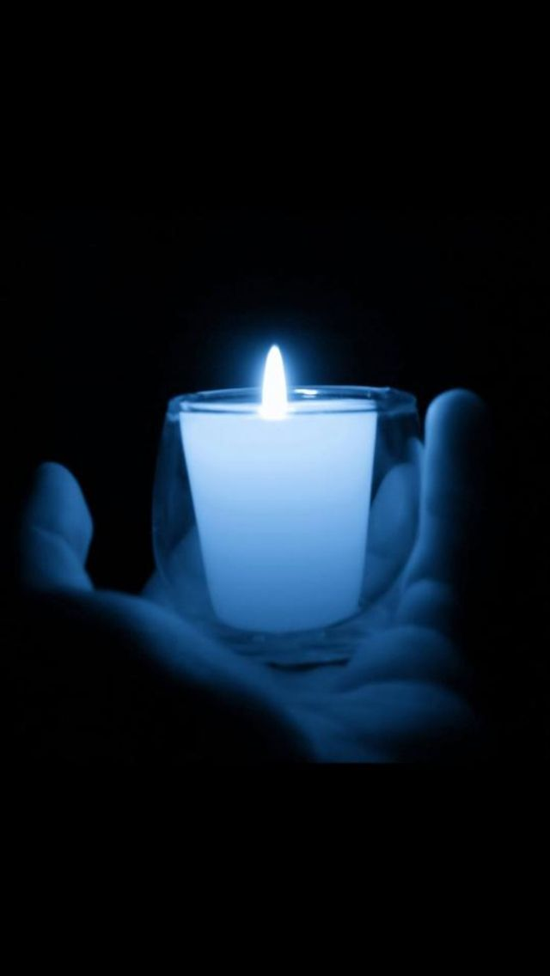Please join us for a simple service of music, readings and a reflection of God’s hope for us and presence with us in feeling what we feel. All are welcome.

Blue Christmas: Friday 22nd December 2023 at 6.30pm in the Church of St John the Baptist, Royston.

Please join us for a simple service of music, readings and a reflection of God’s hope for us and presence with us in feeling what we feel. All are welcome.

Blue Christmas: Friday 22nd December 2023 at 6.30pm in the Church of St John the Baptist, Royston.

Please join us for a simple service of music, readings and a reflection of God’s hope for us and presence with us in feeling what we feel. All are welcome.

