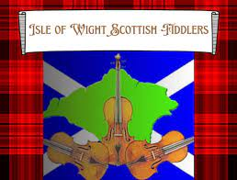
“ We fiddle for fun and fundraise for free”

Saturday
November 15th
7.30pm
St Lawrence Parish Church
Undercliff Drive

With cheese and wine refreshments

Donations towards the bell appeal

