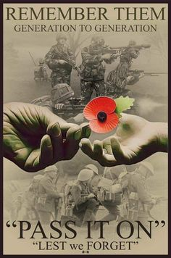

JOIN US ON SUNDAY
9TH NOVEMBER

at the Parish church Undercliff Drive
10.55 by the memorial to
Commemorate the fallen from
St Lawrence followed by
Holy Communion.

Read their histories in a display in church

Everyone welcome

