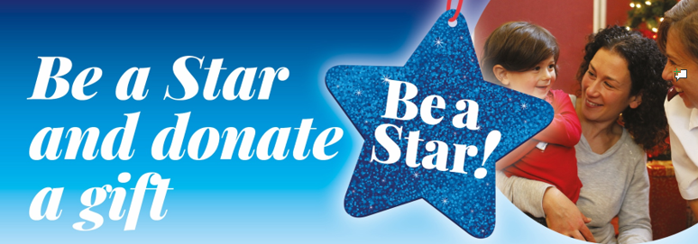

**Last year, The Salvation Army in the UK distributed over 84,000 gifts. In Norwich alone over 850 gift bags were distributed. This year, they’re expecting the number of families requesting help to rise as a result of the ongoing cost of living crisis.**

As in previous years, they’ll be running a Christmas Present Appeal, collecting donated (new) presents until mid-December. Each gift bag given out contains five gifts. One larger present, two smaller presents, a book and colouring or quiz books and stocking fillers.

There will be a **special child-centred Family Service** at

**BERGH APTON CHURCH**

on

**Sunday 16th November at 11 am**

to support this year’s

**Salvation Army Christmas Present Appeal**

You can ‘Be a Star’ by donating and helping to spread the joy of Christmas to families whose children would otherwise not receive a gift.

Bring along, **EITHER TO SCHOOL BEFOREHAND, OR TO THE CHURCH ON THE DAY,** your donations of **new, unwrapped** toys or gifts, for children

and Young People aged 0 – 16

Afterwards, the Bergh Apton team will arrange for them to be taken to the Salvation Army Norwich depot where the gifts will be wrapped before distribution to those in need.

Here are a few gift ideas:

* 0-3 years: dolls, teddy bears, cot mobiles, baby clothes, bath toys, puzzles
* 3-5: dolls and action figures, cars, lorries, colouring sets, pencils, crayons, books, puzzles
* 5-9: educational games & toys, stationery (colouring sets, pencils, crayons, school sets), books, puzzles, wordsearch, crosswords
* 9-12: games and toys, stationery, books, t-shirts, hair accessories, gloves, scarves, hats
* 13-16: books, make-up and toiletries (please try to ensure non-allergic ingredients if possible), gloves, scarves, hats, t-shirts, hair accessories and gift vouchers

There will also be an opportunity at the service to make monetary donations to the Appeal**.**

**Nearly-new toys in good condition can also be donated for sale in Salvation Army shops to raise funds for their valuable work**