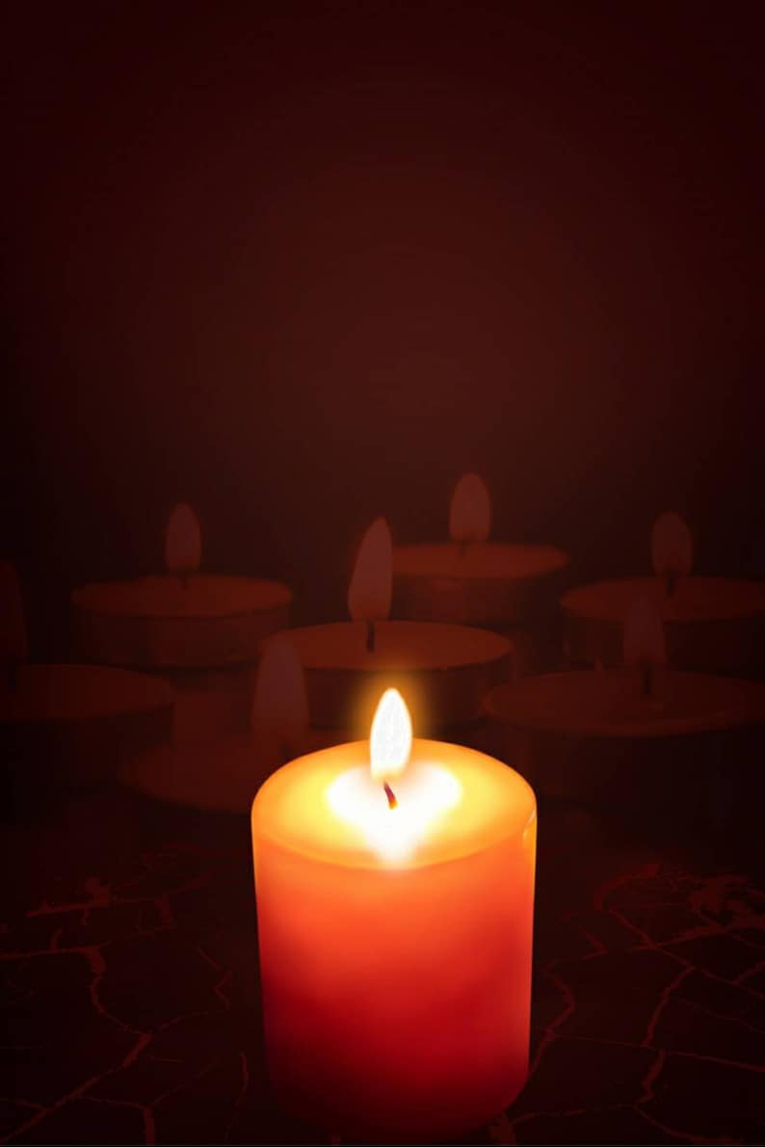

**SUNDAY 2ND NOVEMBER 4pm**

ST. MARY’S CHURCH,

STURMINSTER NEWTON

**All Souls Memorial Service**

To remember loved ones who have died.

**Refreshments will be served in St. Mary’s Church Hall from 3pm**

If you would like someone to be remembered by name during the service, please contact The Vicar, Mary Gubbins ([revd.mary.gubbins@gmail.com](mailto:revd.mary.gubbins@gmail.com) or call 07440680387)