St Leonard and St Catherine Church
Remembrance Sunday

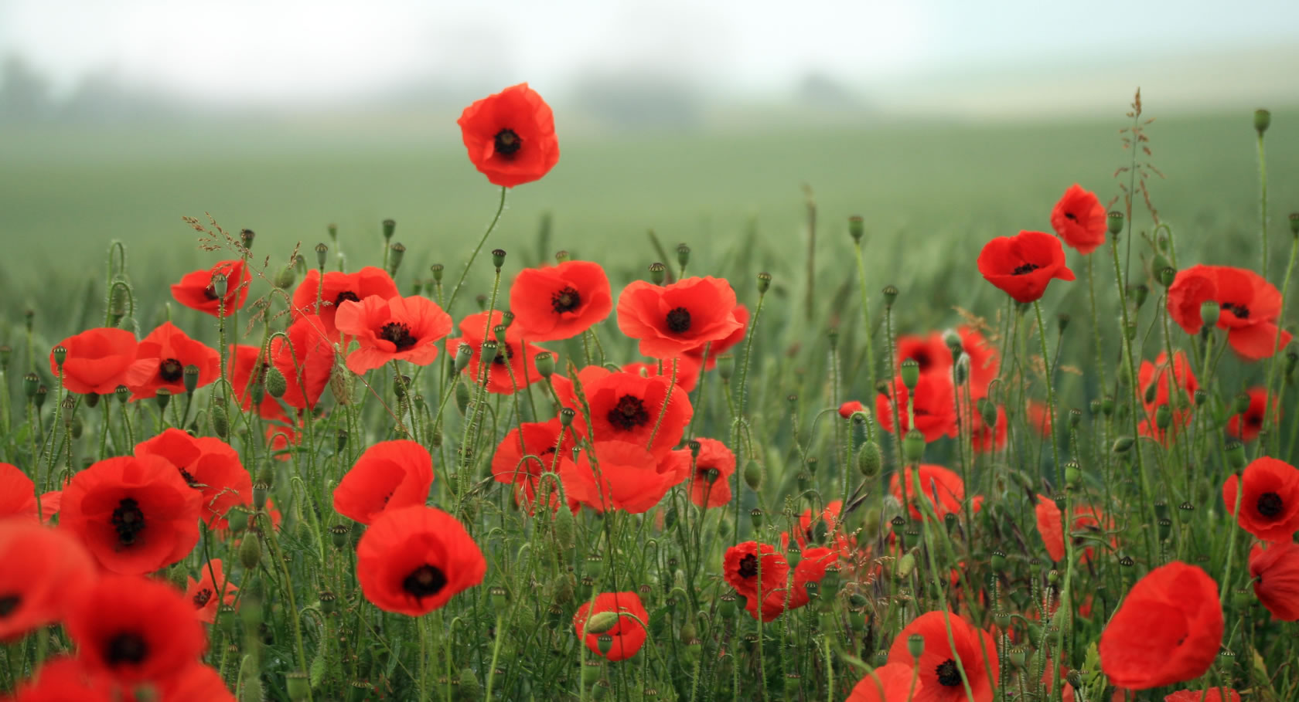

Sunday 9th November

10am Remembrance Service in church, Act of Remembrance at 10.45am
at the War Memorial

