Christmas  FREE  ENTRYY  Kitchen  Saturday, 29th November  11.30am – 2.30pm  at  St Gabriel’s Parish Church  Bishop’s Road,  Sedgley Park,  M25 0HT | 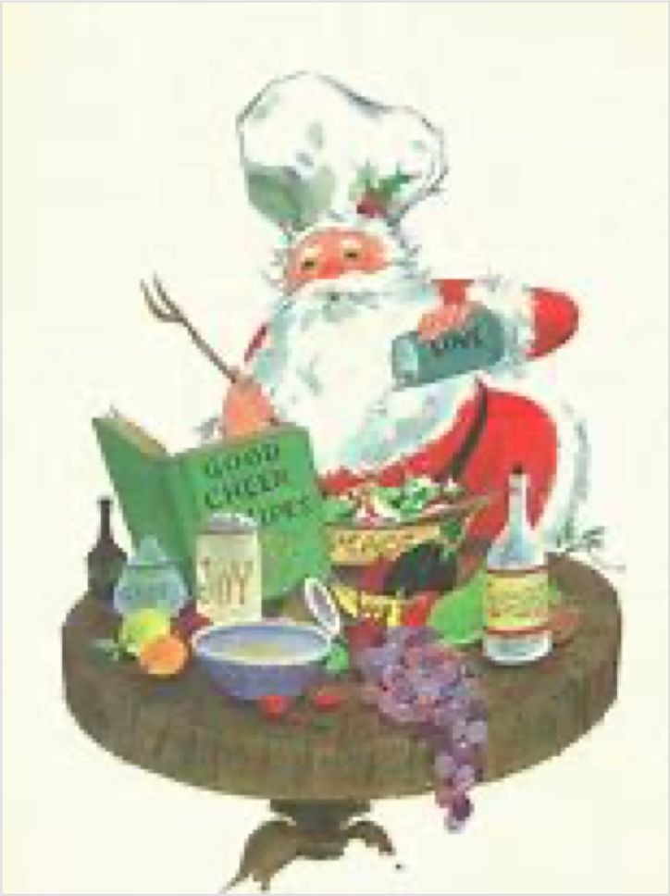  *Chef Tim invites you to his table for a free lunch*
  Carols around the tree at 1.30pm  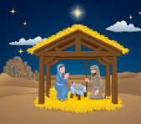  Experience the Nativity Grotto    A Grand  Christmas  Raffle |  | And browse the Stalls:  - Home Bakes for a sweet treat  - Mulled Wine and Christmas Cake  - Prize-Every-Time Tombola  - Table Top Sale  - Silent Auction  - Christian Books and Gifts
*You can be sure of a warm welcome*

