Terence Blacker’s  Christmas Cracker    In the season to be jolly, there’s no better way than to get in the mood than with a funny,  toe tapping celebration of  Christmas past and present with  local singer-songwriter, author and performer  Terence Blacker  Described by Gyles Brandreth as ‘witty wistful,  wonderful – a treat’  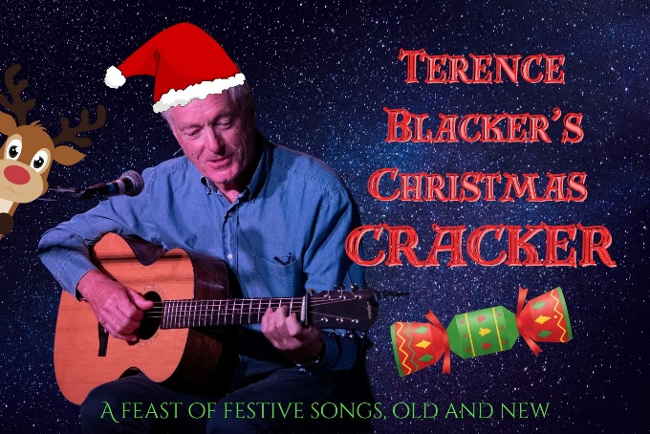  ‘We need cheering up right now and this singer-songwriter is just the ticket.’ - Sunday Times  8pm Thursday 27th November 2025  Dickleburgh Village Centre  Harvey Lane IP21 4NL | A Benefit Show to raise funds for St Mary’s Church, Rushall  ────  Doors open 7.30pm  Show start time 8pm  Entry for 14-year-olds + only  ────  Tea, coffee, soft drinks & biscuits will be available  &  alcoholic drinks can be purchased from Mikey’s Bar  Tickets £12  Contact Linda Perkins either via Email: lindyjperkins@gmail.com  or  Mobile:  07540 051496  or  if available, on the door, on the night

