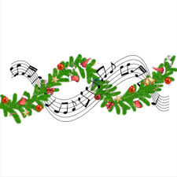
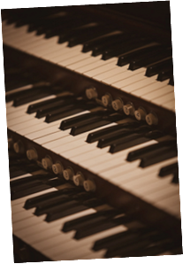

Scott’s Christmas
Music Recital
A selection of seasonal music to enjoy, listen to and be part of.

Saturday 29th November
7:30pm in St Leonard’s church

£10 ticket to include
cheese and wine refreshments
Raffle
Tickets available from Shirley 01630 647574 & Dianne 01630 647591

