Young Generations
We meet on the first Sunday of every month 6pm-8pm in St Oswald’s Church where we catch up with each other’s news, share a meal, play games, have craft activities, encourage discussions about ourselves and our community.

Pop in and have a look- it looks great!

For more information, contact Faye: faye_1981@hotmail.co.uk

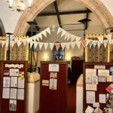
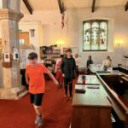
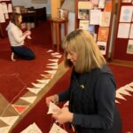
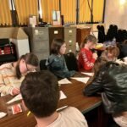
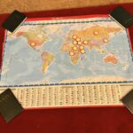
Images from May 2024

Come and join us – contact Faye

