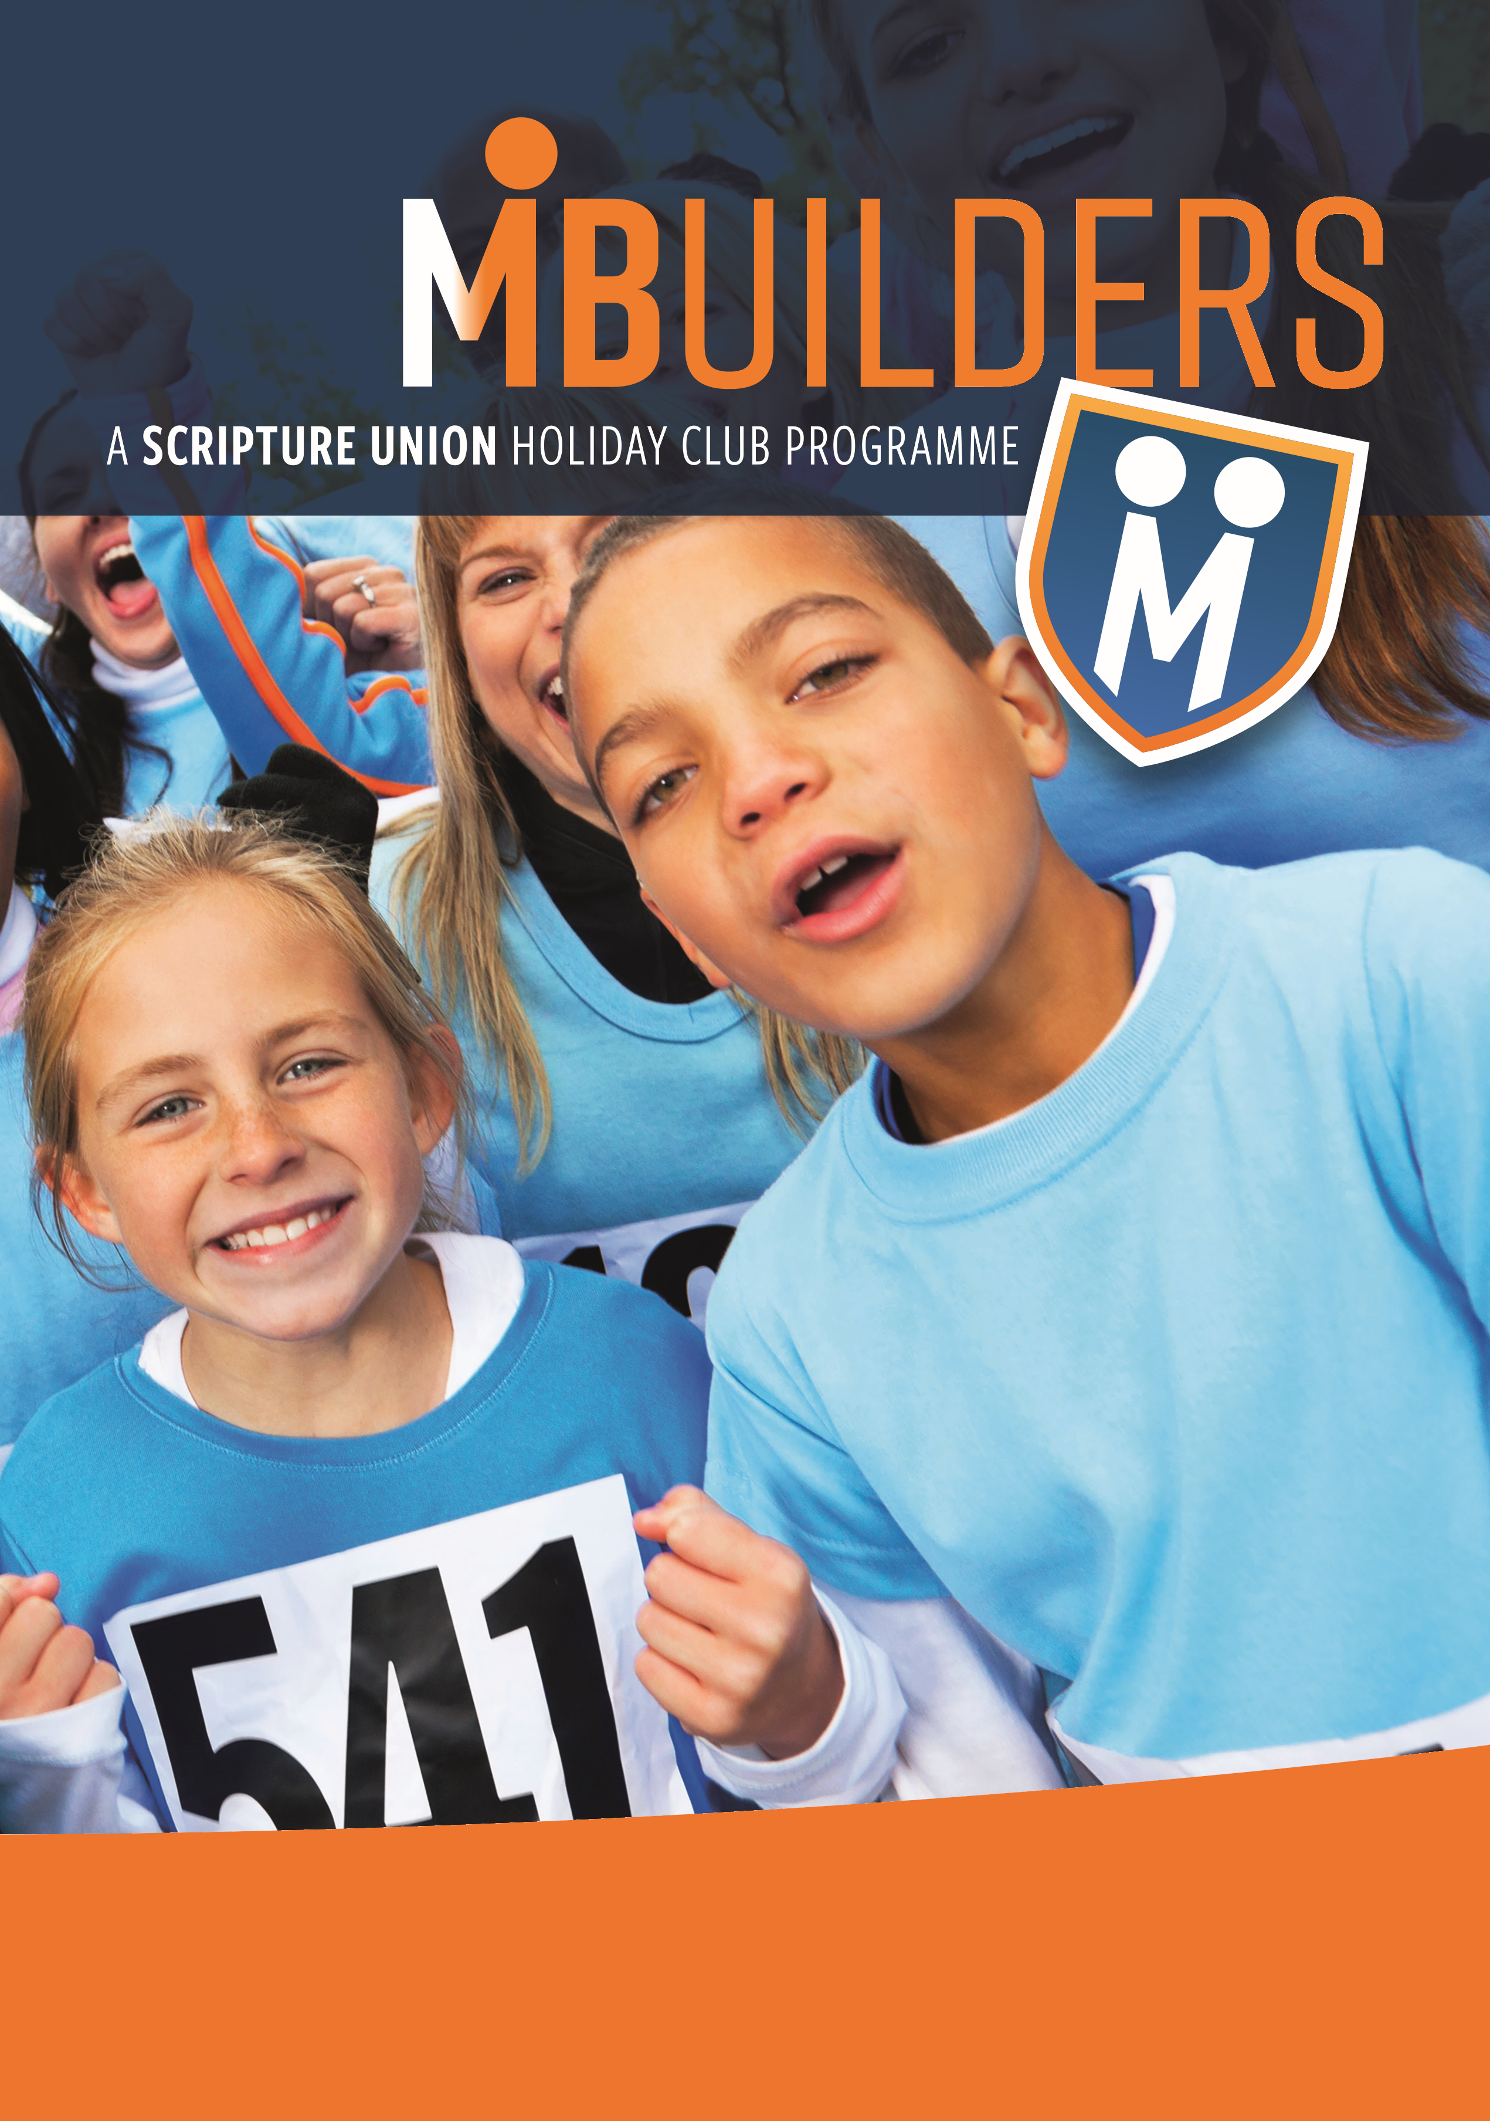
Yr R to Yr 6
21st to 23rd October 2025
10am-12.30pm (or 1.15pm if bringing a packed lunch)
St. Paul’s Church Parkwood, ME8 9SR
For an application form, email: posgchildrensteam@gmail.com
TEAM
Join us for a fun filled morning of stories, games, singing, craft and drama!

