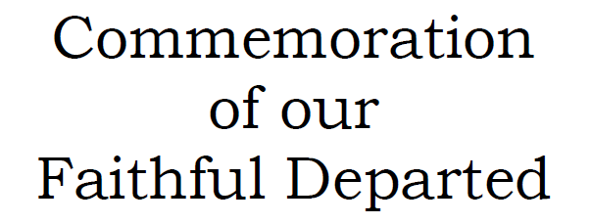

**You are warmly invited to join us for a**

**Service of Commemoration of our Loved Ones Departed**

**On**

**Sunday 2nd November at 3pm**

**in St Mary the Virgin, Elham**

**The names of Loved Ones will be read out**

*For further details and to request a name to be read out contact:*

**Benefice Administrator:** Alison Dale 07985025381 (Wed, Thu & Fri), [beneficeadmin@elhamvalleygroupofchurches.co.uk](mailto:beneficeadmin@elhamvalleygroupofchurches.co.uk)