St. Stephen’s Church
Fradley
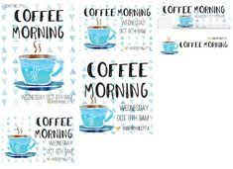Coffee
Morning
Saturday
25th October
10am-12 noon
Bacon Baps
Coffee & Cakes
Homemade Produce
Stalls

