**Joint Harvest Thanksgiving**

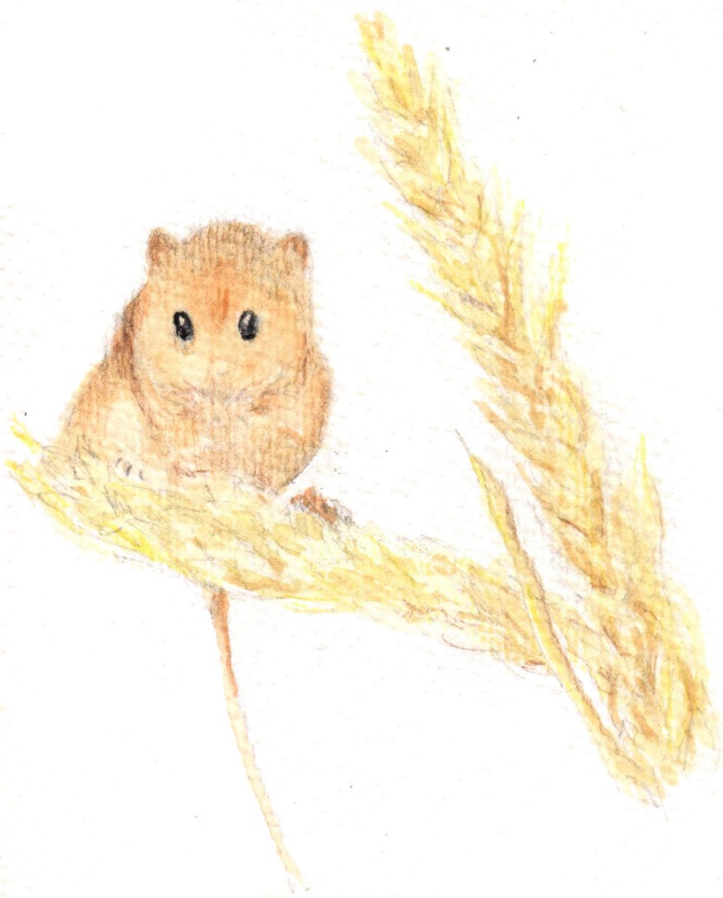 **Holy Communion Service**

**at St. Mary’s Church**

**Sunday 5th October**

**at 11am.**

This is a joint service with the Methodist Church, and all are welcome. The service will be followed by a ‘bring and share’ Harvest Lunch in St. Mary’s Church Hall where we will be joined by members of The Christian Fellowship.

Any harvest gifts brought to this service will be donated to the Pantry at The Vale Family Hub.

Please contact Revd Mary Gubbins on 07440680387 if you have any questions.