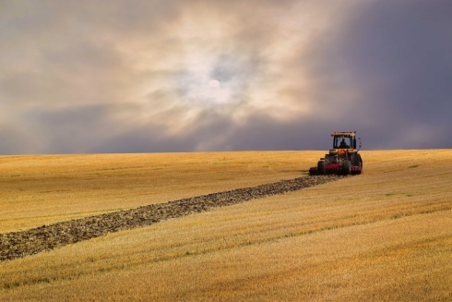

***Harvest Supper***

***Friday 10 October***

***Lydlinch Hooper Hall***

***At 7.00pm***

***Tickets - £12.50***

***Children under 12 - £5***

***(Bring Own Bottle and Glass)***

***Tickets – Sarah Frizzle – 07741 652 713***

***Christine Tuffin – 07833 144 260***

***All Welcome***