

**An evening**

**of**

**Fun, Mystery, and Betrayal**

**THE TRAITORS**

**Saturday 18th October**

**Pulham Market Memorial Hall**

**6.30pm for 7.00pm**

Based on the TV series ‘The Traitors’

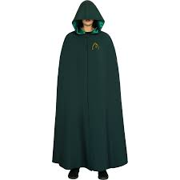

**Delicious three course meal**

**Bar**

**Tables of 8**

**What will you be?**

**Faithfull or Traitor**

**Tickets £25.00 pp from Laura - 07767838208**

**Presented by Pulham Market Church**

**In aid of church projects**