**presents**

**The Story of Oberleutnant Joachim Schwartz**

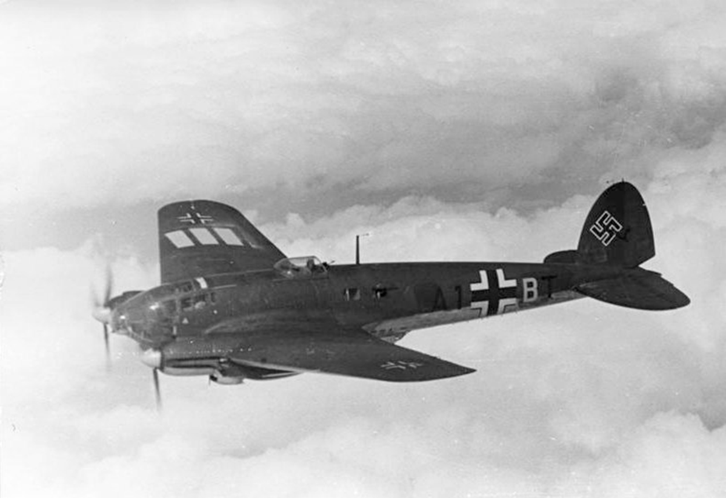 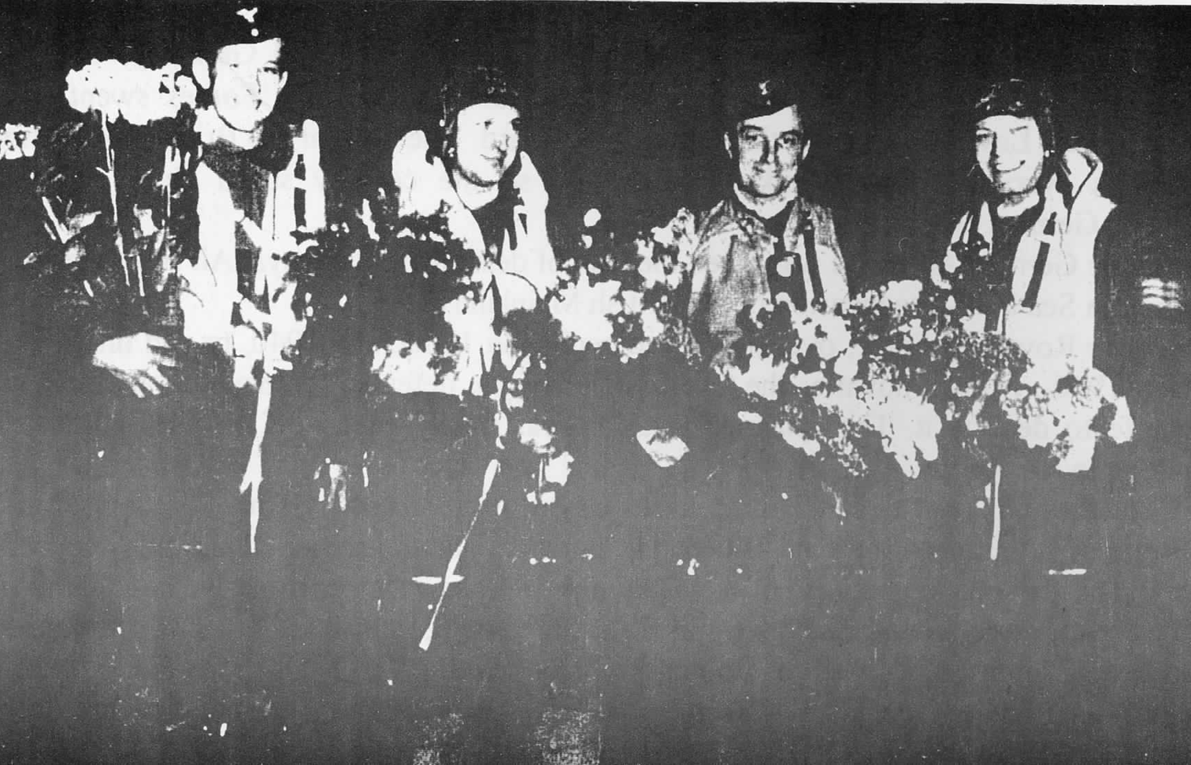

‘Somewhere in the corner of a Foreign Field’

Presented by Lyn Tyler Chair of FHG

Thursday 25th September 7.30pm

St Stephens Church Fradley WS13 8NL

Mulled Cider and Savouries served

Admission Free Donations accepted