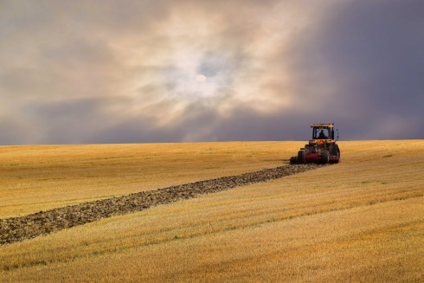 ***Harvest Festival*** 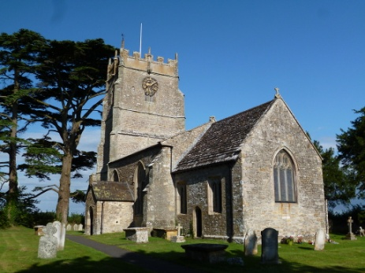

***Evensong***

***At Lydlinch Church***

***Sunday 5 October***

***At 6.00pm***

***Auction of Produce and Refreshments after***

***All Welcome***