The Benefice of Healey,
Hamer and Belfield

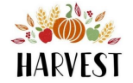

Christ Church,
Healey
Sunday 28th Sept
10.00am

St Ann’s, Belfield
Sunday 5th October
10.30am

Supporting the Farming Community Network and Rochdale Foodbank.

You are welcome to join us at either of these services and for refreshments afterwards.

