**The Benefice of Healey,**

**Hamer and Belfield**

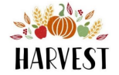

Christ Church,

Healey

Sunday 28th Sept

10.00am

St Ann’s, Belfield

Sunday 5th October

10.30am



**Supporting the Farming Community Network and Rochdale Foodbank.**

**You are welcome to join us at either of these services and for refreshments afterwards.**