THREE PARISHES COMMUNION

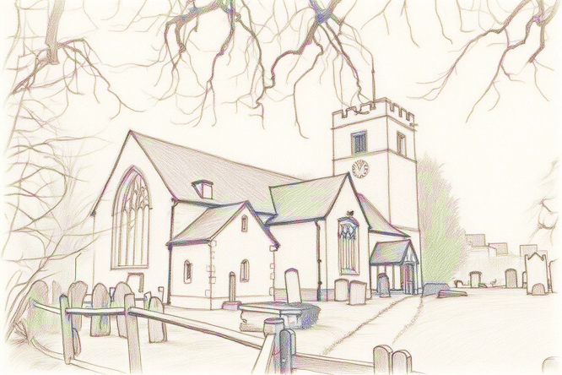 | on  SUNDAY 12 OCTOBER  10 AM
at  ST MARY’S  GREAT PARNDON  CM19 4HT | 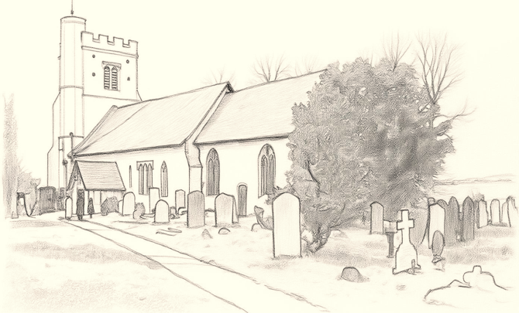
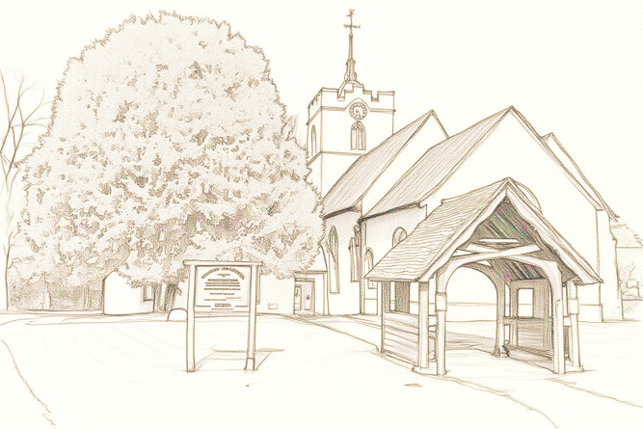 | followed by  REFRESHMENTS

ALL WELCOME!

