**St Cuby Church**

**invites you to**

**HARVEST BREAKFAST**

**In the Church Hall**

**from 9.30 am on Sunday 5th October**

**followed by**

**HARVEST CELEBRATION**

**at 10.30 am in the church**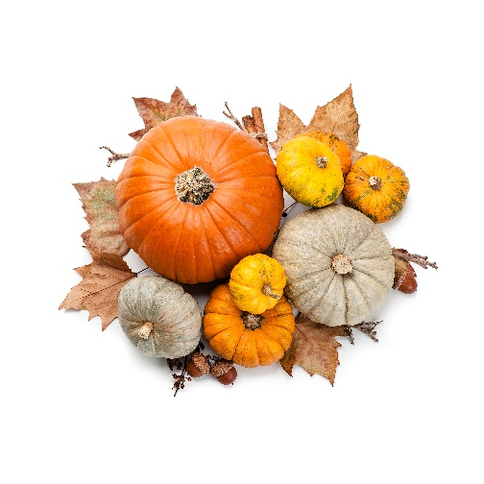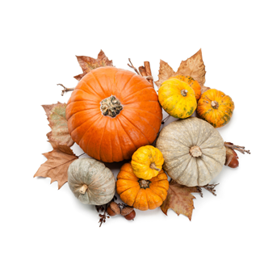

**Gifts of tinned or packet food**

**will be donated to Truro Food Bank**

**We will be supporting Ripple Effect**

**- a charity working with farmers in Africa**