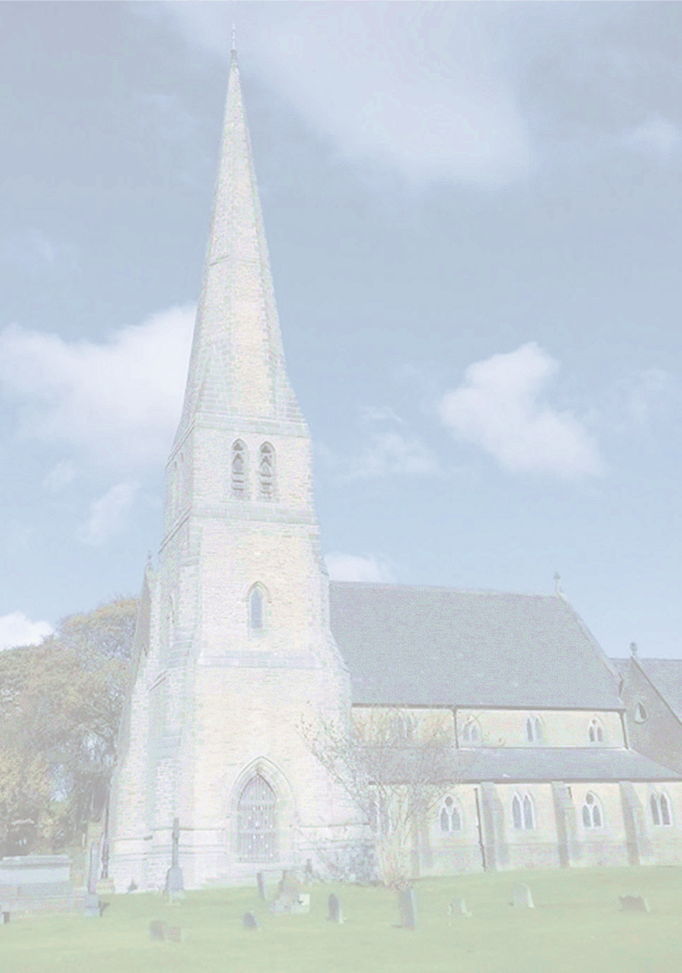Christ Church, Healey

Invites you to our

175th Anniversary

Celebration Service

Thursday

16th October 2025

7.00pm

Service of thanksgiving and Celebration

Preacher:

Right Rev Mark Davies

All welcome

