St Mary’s Church, Swine

OPEN DAY
Saturday 2nd August 2025
10am - 4pm
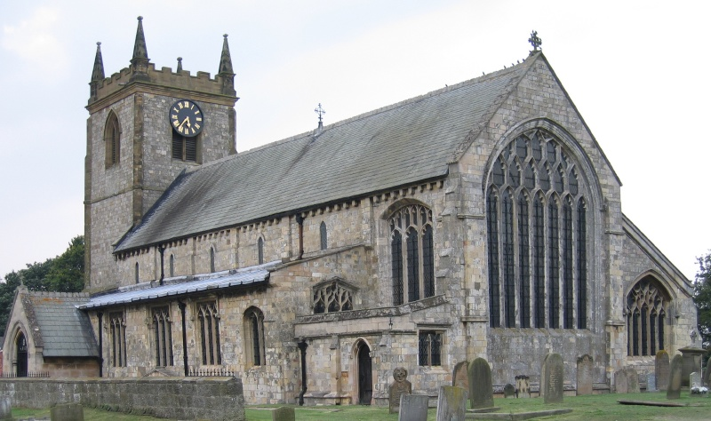

The church will be open from 10am
Silver Collection at the door

It’s a perfect opportunity to look at this Grade I listed
11th Century Medieval Priory Church
Soak in all its history, our booklets will help

Included this year we have on display
Archived records
Swine history
This has been very popular in the past for those who love history

STALLS - Bric-a-brac, Books, Garden plants, Tombola
ALSO: Chris Ellis’s Art Exhibition

100 Club will be drawn
(If you want to join please ask)

Refreshments
Tables outside weather permitting

In aid of church funds
Please help to keep our church open to all

