Next Sunday

31st August 2025

11th Sunday after Trinity

10.00am

An All-Age Service of Worship
Led by
Don McQuillen-Wright

at St Gomonda’s Church, Roche
a combined Blackmore Benefice service.

If you would like a lift please speak to Jim.

Dates for your diary;

24th August Cream Teas continue in church, 3.00 till 5.00pm. The church will run these on Sundays this year. Please enter your name on the list at the back of church if you are able to help. There are still spaces on 24th & 31st August.

6th September 10.00 till 12.00noon.
Book & Bake. Please put it in your diary because it is not in Granite Towers. Please bring your cakes etc on the morning of the sale, and books and bric-a-brac at virtually any time.

Bishop Hugh Nelson will be leaving us to take up his new position as Bishop of Worcester. See letter at the back of church.

Please pray for;-
Holly Pat Weston
Elizabeth Cleare Magi & Vern
Gill Moore Emma Slater
Jenny Filer Toni Olsson
Sandra George Robin Burley
Vanessa Jeffries Helen Peacock
Sadie Rawlings

RIP; Sue Williams (Jule’s Mum)

Years mind; Ralph Keam (2017)

Revd Canon Paul Arthur has been invited to take up the commission of Strategic Rural Dean for St Austell. Details of Commissioning Service are at the back of church.

Food Bank; Thank you for your continued support.
This week’s wish list;-
Long life fruit juice
Tinned custard
Tinned fruit
Jam
Tinned potatoes
and Instant coffee

We shall be hosting the Pop-up Café presented by The Village Shop & Post Office on Mondays to Saturdays in August & September starting on 1st August. See note over page.
10.00am till 3.00pm

If you have items suitable for inclusion in next Sunday’s leaflet please ring Jim on 01726 850553 or email jim.cleare@btinternet.com
by 9.00pm on Saturday

Welcome to

Luxulyan Church

SS Cyriacus & Julitta

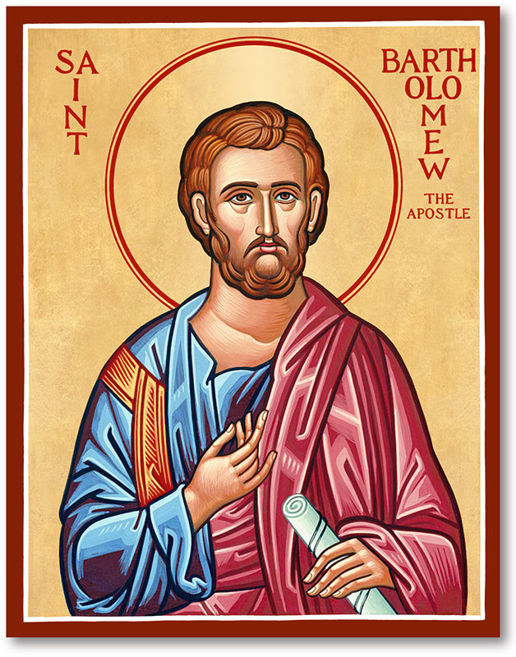

24th August 2025

Bartholemew the Apostle

11.00am
Sung Eucharist
with
Archdeacon Kelly Betteridge

1st reading Jim
2nd reading Liz
Intercessions Shelley
Preist’s assistant Shelley

Please take this leaflet home
Bartholomew the Apostle Red
Collect
Almighty and everlasting God,
who gave to your apostle Bartholomew grace truly to believe and to preach your word:
grant that your Church
may love that word which he believed
and may faithfully preach and receive the same;
through Jesus Christ your Son our Lord,
who is alive and reigns with you,
in the unity of the Holy Spirit,
one God, now and for ever.

FIRST READING Isaiah 43.8–13
A reading from the book of the prophet Isaiah.
8 Bring forth the people who are blind, yet have eyes, who are deaf, yet have ears!
9 Let all the nations gather together, and let the peoples assemble. Who among them declared this, and foretold to us the former things? Let them bring their witnesses to justify them, and let them hear and say, ‘It is true.’
10 You are my witnesses, says the LORD, and my servant whom I have chosen, so that you may know and believe me and understand that I am he. Before me no god was formed, nor shall there be any after me. 11 I, I am the LORD, and besides me there is no saviour.
12 I declared and saved and proclaimed, when there was no strange god among you; and you are my witnesses, says the LORD.
13 I am God, and also henceforth I am He; there is no one who can deliver from my hand I work and who can hinder it.

SECOND READING Acts 5.12–16 A reading from the Acts of the Apostles.
12 Many signs and wonders were done among the people through the apostles. And they were all together in Solomon’s Portico.
13 None of the rest dared to join them, but the people held them in high esteem. 14 Yet more than ever believers were added to the Lord, great numbers of both men and women,
15 so that they even carried out the sick into the streets, and laid them on cots and mats, in order that Peter’s shadow might fall on some of them as he came by.
16 A great number of people would also gather from the towns around Jerusalem, bringing the sick and those tormented by unclean spirits, and they were all cured.

GOSPEL Luke 22.24–30
Hear the gospel of our Lord Jesus Christ according to Luke.
24 A dispute also arose among the twelve as to which one of them was to be regarded as the greatest.
25 But he said to them, ‘The kings of the Gentiles lord it over them; and those in authority over them are called benefactors.
26 But not so with you; rather the greatest among you must become like the youngest, and the leader like one who serves.
27 For who is greater, the one who is at the table or the one who serves? Is it not the one at the table? But I am among you as one who serves.
28 You are those who have stood by me in my trials;
29 and I confer on you, just as my Father has conferred on me, a kingdom,
30 so that you may eat and drink at my table in my kingdom, and you will sit on thrones judging the twelve tribes of Israel.’

Post Communion
Almighty God,
who on the day of Pentecost
sent your Holy Spirit to the apostles
with the wind from heaven and in tongues of flame,
filling them with joy and boldness to preach the gospel:
by the power of the same Spirit
strengthen us to witness to your truth
and to draw everyone to the fire of your love;
through Jesus Christ our Lord.

Copyright acknowledgement (where not already indicated above):
Scripture quotations are from New Revised Standard Version Bible: Anglicized Edition, copyright © 1989, 1995 National Council of the Churches of Christ in the United States of America. Used by permission. All rights reserved. Collect and Post-Communion Prayer from Common Worship: Services and Prayers for the Church of England, copyright © The

Please note; when the Pop-up Café is not open the church will be closed.
If you wish to get into church after 3.00pm please ring 01726 850 553
or call at St Cyor’s House

