Wylam at War

80th Anniversary of the end of the War

16 August 2025
2pm- 4pm
Traditional Afternoon Tea in Church Hall
Exhibition on Wylam at War in Church

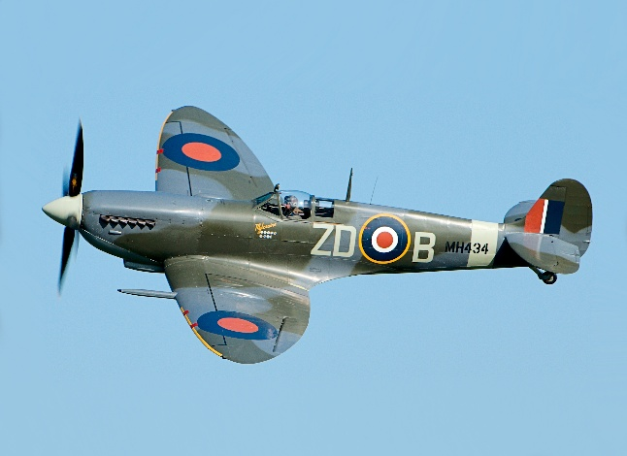

1940s outfits may be worn

ALL WELCOME

