The Benefice of Healey,
Hamer and Belfield
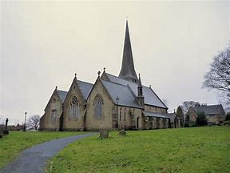 |  | 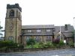

Joint Services, 2025

Sunday 31st August
At Christ Church, Healey 10.00am
Light lunch after in the hall

Sun 30th November
At St Ann’s,
Belfield 10.30am
Advent 1
Light lunch after in the hall

You are welcome to join us at either of these services
or any Sunday.

