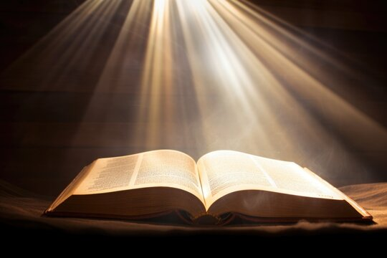

**Your Bible is not just for Sunday**

**The Gospels – John**

|  |  |  |  |  |  |  |
| --- | --- | --- | --- | --- | --- | --- |
| **Sunday**  **John 1:1 Artwork | Bible Art**  John 1 -3  The Word Became Flesh | **Monday**  **Jesus and the Woman at the Well - Jesus Film Project**  John 4 -6  Meetings & Miracles | **Tuesday**  **The Feast of Tabernacle's Connection With Jesus the Light of the World -  HubPages**  John 7 – 9  Feast of the Tabernacles | **Wednesday**  **Jesus educated Mary and Martha in a better way – Deseret News**  John 10 – 12  Jesus Wept Triumphal Entry | **Thursday**  **Jesus, Our Compassionate Servant Model**  John 13 – 15  Servant King  Comforter | **Friday**  **Prayer at Gethsemane**  John 16 -18  Teaching  Prayer & Betrayal | **Saturday**  **Download Jesus, Empty, Tomb. Royalty-Free Stock Illustration Image - Pixabay**  John 19 -21  Death, Resurrection Joyful Reunion |

**Every day is a Bible day**

**Spend time each day with God.**